SARMISTHA PRIYADARSINI DAS  At- padasahi(ghantiali)  Po- Arei  Dist- Jajpur(Odisha)  Pin- 755027  Mobile No. – 9337126520  Email Id- das1998sarmistha@gmail.com | 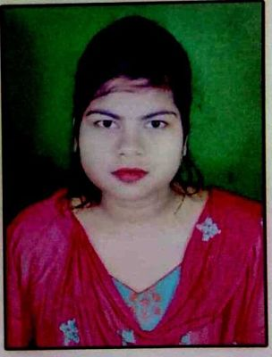
Objective
To seek a vigorous and challenging career an organization strives for excellence with my knowledge and team effort while making positive contribution to promote the individual opportunity and professional
growth.

Academic Qualification
Sr. No. | Class | Bord/University | Year | Percentage
1 | High School | BSE, Odisha | 2014 | 77.33
2 | Intermediate | CHSE, Odisha | 2016 | 49.34
3 | B.sc(science) | Utkal university | 2019 | 74.34

Computer Skill
- Post graduate diploma in computer application
Strength
- Quick learner, good communication and interpersonal skill
- Team player, leadership qualities, High energy level etc
Hobbies
- Reading books and magazines
- Listening music, Net surfing
Personal Details
Name : Sarmistha Priyadarsini Das
Date of Birth : 15/06/1998
Father Name : Manoj Kumar Das
Gender : Female
Nationality : Indian
Declaration
I do here by declare that the statement made in this document are true to the best of my knowledge and belief.

Date: 28/12/2020 SARMISTHA PRIYADARSINI DAS
Place: Padasahi

