MBA- FINANCE MANAGEMENT DIPLOMA IN MANAGEMENT

Abhimanyu sahu abhimanyusahu08@gmail.com 9114585875


CAREER OBJECTIVE

To get an opportunity where I can make the best of my potential and contribution to the organisational growth.

 |  | SKILLS
Managerial skill |  | SKILLS
Managerial skill | Team work, collaboration, communication, problem solving & leadership
 | qualities

 |  | EXPERIENCE
Jun-2022 - Jul-2022 |  | EXPERIENCE
Jun-2022 - Jul-2022 | SN Ventures
Auditor | Physical stock varification

Degree/Course


MBA-fm


BCOM

Diploma in

management

Intermediate in

commerce


Matriculation

 | EDUCATION
Institute/College | University/Board
Gangadhar meher | GMU
University | GMU
Gangadhar meher | CBCS
University | CBCS
Odisha State open | OSOU
University | OSOU
Anmol college of+2 | CHSE
Sc. & Com. | CHSE
Sason High school | BSE
 | STRENGTHS

Percentage/ | Year of Passing
CGPA | Year of Passing

79.12 % | 2022
58 % | 2020
71 % | 2020
74.33 % | 2017
58 % | 2015
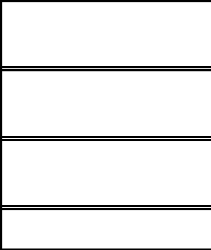

Hard working & Highly dedicated to the given job, Self motivated & discipline person

AREAS OF INTERESTS

Learning new things, reading & playing chess

 |  |  | HOBBIES
Traveling & Listening music |  |  | HOBBIES
 |  | PERSONAL DETAILS
Address
Address | Sason
 | Sambalpur, Odisha, 768200
Date of Birth | 28/09/1999
Gender | Male
Nationality | Indian
Marital Status | Single
Languages Known | English, Hindi, odia

DECLARATION

I hereby declare that all the information given above is true and correct to the best of my knowledge.

Abhimanyu sahu

