CURRICULUM VITAE

PERSONAL INFO:-

KULJEET SINGH
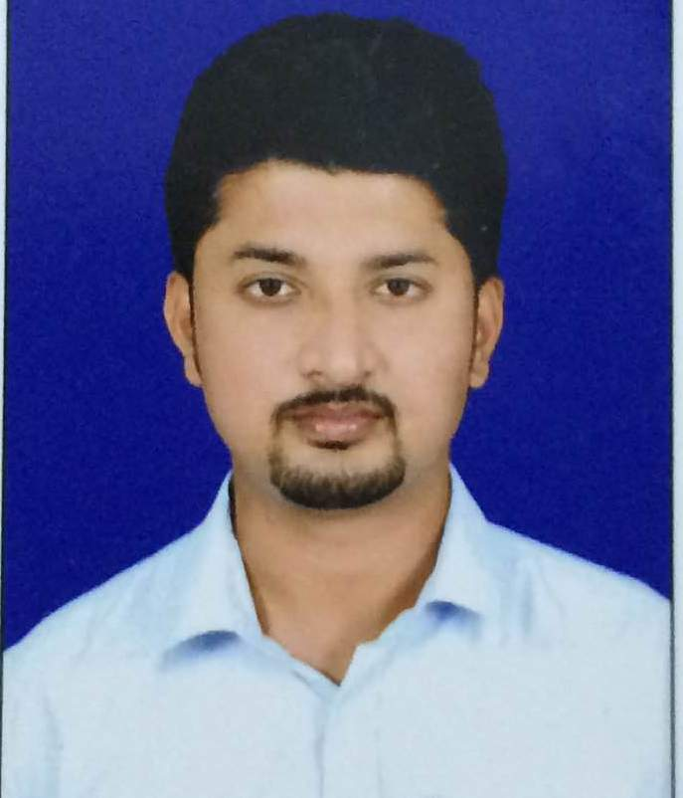
ADDRESS:- House no. 1376,
New Indira Colony,
Manimajra, Chandigarh
DOB :- 19th September 1992
MARTIAL STATUS:- Unmarried
NATIONAL :- Indian
Email :-kuljeetsingh1909@gmail.com
Phone:- 09888406811

ACADEMIC QUALIFICATION:-

Examination | Board/ University | Institution | Passing  Year
SECONDARY  (10th ) | ICSE | St. Vincent's Convent Senior Secondary School, Balasore, Odisha | 2009
HIGHER  SECONDARY  (12th ) | CHSE  (Odisha) | Fakir Mohan College,  Balasore | 2011
BCOM | NORTH ODISHA UNIVERSITY | MPC Autonomous college,Baripada, Odisha | 2014
PGDM | All India Management Association | United School Of Business Management | 2016

CAREER OBJECTIVE :-
To achieve professional excellence and quality experiences.
Looking for responsible and challenging career, where my banking knowledge, skills can be effectively utilized and contributed for growth of the organization along with mine.
PROFESSIONAL QUALIFICATION: -Advanced Diploma in Computer Education.
WORK EXPERIENCE:-
- Worked as a Store manager at B S Enterprises for 2 years from 25/09/2010 till 27/09/2012
- Worked as an Financial Service Consultant in Bancassurance Channel in ICICI Prudential Life Insurance for 1.2 year from 10/07/2016 till 23/09/2017
- Worked as a Channel Sales Manager in bancassurance channel at Apollo Munich Health insurance from 09/01/2018 till 05/01/2019
- Working as a HR Executive at Evable India from 10/02/2020 .
- ACHIEVEMENT :-
- Got promoted as a Channel Sales Manager from Senior Channel Sales Officer on 1st May, 2018 in Apollo Munich Health Insurance.

LANGUAGE:-
English,Hindi,Oriya,Punjabi.
EXTRA CURRICULAR ACTIVITIES:-
- Playing chess, carom
- Listening songs

PERSONAL STRENGTH:-
Optimistic
- Leadership
- Self – motivated
- Creative
- Interpersonal Skills
- Quick Learner

CONCLUSION:-
I hereby acknowledge & authenticate, every bit of information mentioned in this document is correct by all means.

DATE: Signature
PLACE:

