CURRICULUM –VITAE

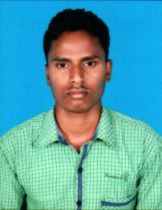
Name - JAGANNATH BAR
C/O - ACHINTA BAR
At - Chandrabali
PO - N.M Padia
Ps - Bhograi
Dist - Balasore
State - Odisha
Pin - 756037
Mob. No - 9658999701

Email - jagannathabar@gmail.com

Career OBJECTIVE

- To work in a leading organization this promotes learning and growth utilizing my skill for both personal and career growth and continuously service for satisfaction and challenging job.

QUALIFICATION

- Passed HSC from BSE, Odisha in the year of 2011 with 59%.
- Passed I.com from F.M junior college Balasore in the year of 2013 with securing 54%.
- Continuing B.com in last year in F.M college Balasore.
- Tally ERP.9

STRENGTH

- Hard working, leadership, honesty ,sincerity ,and target oriented .

PERSONAL DETAILS
Name - Jagannath bar

Father’s Name - Achinta bar

Date of Birth - 15-03-1996

Gender - Male

Marital Status - Unmarried

Nationality - Indian

Religion - Hindu
.
LANGUAGE KNOWN

- Odia, Bengali, Hindi & English

HOBBIES

- Playing Cricket
- Cycling
- Visit to new place

Declaration

I do hereby declare that all the information are above made by me are true & correct to the best of my knowledge & belief. I assure to discharge assigned responsibility honestly & diligently.
Date-26/07/2020 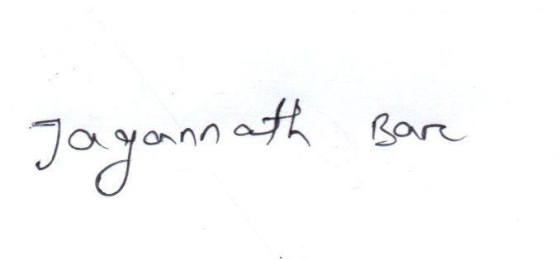
Place-Balasore Signature

