CURRICULUM VITAE
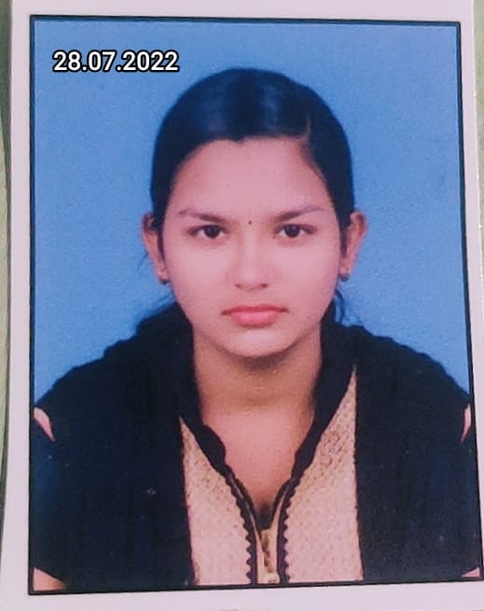
SHUBHASHREE MOHAPATRA
Village-Hiratikiri
Po-Sergarh
p.s – khantapada
dist – Balasore,756060
mobile: +91-8984048438,9861318155
e-mail : lipi986131@gmail.com

OBJECTIVE
To pursuer a carrier in a growing and reputed organization that can fully utilized my abilities and skills and simultaneously advance my carrier . My Education and my work experience has given me enough confidence to achieve my Goals .

EDUCATIONAL QUALIFICATION:

Degree/course | Institution | University/Board | Percentage | Year of passing
HSC | Saraswati shishu vidya mandir,Manikhamb | B.S.E Odisha | 80.5 | 2017
+2 SCIENCE | Wisdom science h s schoo ,Issan Nagar | CHSE Odisha | 52.5 | 2019
+3 SCIENCE  Physics hons | Basic sc. and tech. | F.M University | 70.30 | 2022
MCA | Bcet ,Balasore | BPUT Odisha | continuing

COMPUTER PROFICIENCY:
- PGDCA Course in PENTASYS COMPUTER EDUCATION, Sergarh, Balasore
- Sound knowledge of MS OFFICE,MS WORD,MS EXCEL.
- Knowledge of Operating System .

ADDITIONAL Skills:
- Excellent communication.
- All official related work.
- Pro efficiency in computer.
- Punctual and Smart work.
LANGUAGE SKILL :-
C programming,html

PERSONAL DETAILS:

Father’s Name :Soroj kumar Mohapatra .
Mother’s Name :Namita mohapatra .
Date Of Birth :08.03.2002
Marital Status :unmarried
Nationality :Indian
Religion :Hindu
Category :General
Gender :Female
Language Known :English,Hindi,Oriya
ADDRESS:AT/PO:Hiratikiri,Sergarh via:Sergarh,Dist:Balasore, Orissa-756060

DECLARATION: I Hear by Declare that the Information Furnished Above is True to the best of my Knowledge and I bear the Responsibility For the Correctness of the above Mentioned Particulars.

Date:
Place: YOUR’S TRULY
Shubhashree mohapatra

