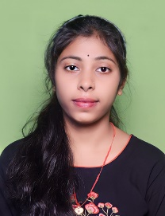
Resume
Pabitra Behera
Email id: pabitrabehera7879@gmail.com
Mobile No: 7848854229.
Address: Dhamanagar , Dist – Bhadrak
, Pin no-756117 , Odisha.
CAREER OBJECTIVE

- Obtain a responsible position in an organization with the best capabilities , skills and knowledge.
WORK EXPERIENCE:
- Fresher

ACADEMIC QUALIFICATION:

- Graduate from Panchayat Degree college barikpur , Bhadrak( F.M university , Balasore).
- 12th from Panchayat Higher Secondary School , Barikpur.
- 10th from jagannath Vidya Mandir , Kankara

PROFESSIONAL SKILLS:
- Basic knowledge of computer .
- Typing

PERSONAL DETAILS:

Father’s Name : Pradeep ku. Behera
Date of birth : 03-04-2002
Gender : Female
Nationality : Indian
Marital Status : Unmarried
Language Known : Odia , Hindi & English
Hobbies : Reading Books

Place:
Date:

