Peeyush kumar Sahu
Vill.charauda,post –Dharsiwa
Dist.-Raipur Chhattisgarh 493221
Mail:-Peeyushsahu2019@gmail.com
Phone:- 9630018401

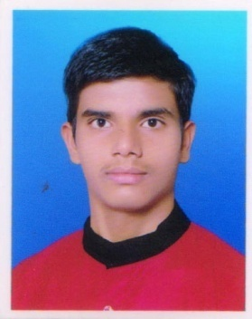

OBJECTIVES:
To obtain a challenging position in organization where my resourceful experience and academic skills will add value & growth of organization.

INDUSTRIAL EXPERIENCE: -

RELIANCE RETAIL Jio Mart RAIPUR
Designation:- DEO (Data Entry Operator )
Department:- RELIANCE RETAIL
Duration:- 01 Apr. 2021 till now
Job Description;-Handling all system related work in Including Inward, Inventory, Outward, Stock take.

ACADEMIC DETAILS: -

Degree/Course | Institution | Year of Passing
CGBSE | Shivam Higher Sec. School Parastarai Dharsiwa | 2017
CGBSE | Shivam Higher Sec. School Parastarai Dharsiwa | 2019
Diploma In Computer Applications | DR. C.V Raman University Bilaspur ( CG ) | 2020
Bachelor Of Commerce | PT.Shyamacharan Shukla collage Raipur (CG) | 2022
Master Of Commerce 3rd | PT.Shyamacharan Shukla collage Raipur (CG) | Appearing

PERSONAL INFORMATION

Name :- PEEYUSH KUMAR SAHU
Fathers name :- MADHUSUDAN SAHU
Mothers name :- SAROJ SAHU
Date of birth :- 21.08/2001
Sex :- Male
Marital status :- Single

Permanent Address :- Vill.charauda,post –Dharsiwa
Dist.-Raipur Chhattisgarh 493221
Nationality :- INDIAN
Hobby :- Music,
Language known :- Hindi, English
Current salary :- 16700/MONTH
Expected salary :- 20000 APROX

Extra Knowledge:-
Operating SAP (Software Application Program)
Operating TMS (Transport Management System)
Microsoft Office
Tally ERP 9 & Tally Prime

STRENGTH

• Self Confident
• Ability to handle the any situation
• Team leader and working.

Declaration:-

Hereby I declared that all above information mentioned are true to my knowledge.

Date:- Your Faithfully
PEEYUSH KUMAR SAHU

