curriculum vitae
subashis barik 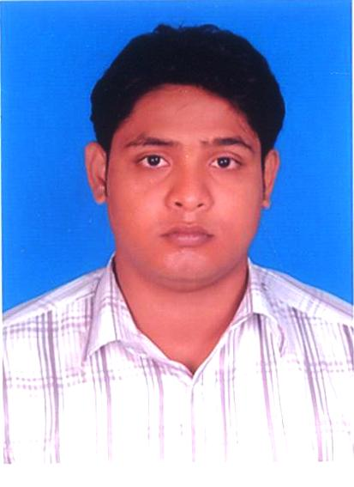
E-mail:- bsubashish160@gmail.com
Contact: -+91 9658112500,

Career Objective
To become a part of result oriented and highly successful team involved in implementing innovative and new ideas in tune with quality standards and present day technologies with a solid progressive company which offers opportunity for career advancement and to evolve as a successful professional, consistently mapping business to the latest technology with my skill and abilities in a dynamic, professional and creative environment
Strength
Strong Determination, Hard working, self confidence, positive attitude, Practical, loyal, analytical, & I love to work with team & motive it.
.
Diploma In Electrical Engineering With 10 yr Work Experience In Electrical Maintenance.
INDUSTRIAL WORKING EXPERIENCE:
- Feedback Power Operations and Maintenance Services (P) Limited, in Korba West Power Company Limited, Group of Avantha Power & Infrastructures Limited, (2X600MW) power project, Raigarh, Chhattisgarh.

Duration: From 1stNov 2014 to 21 Nov 2016
DESIGNATION: - Jr.Engineer
2) Chennai Radha engineering (P) ltd, in Vedanta Alumina (p) ltd group of power plant (3X30MW) in Lanjigarh, Kalahandi
Duration: From : 21 Nov 2016 to 23 march 2023
DESIGNATION: - Sr.Engineer
3) Pradhan associate P) ltd, under Vedanta Alumina (p) ltd group of refinery (under project expenses area) Lanjigarh, Kalahandi
Duration: From : 1ST APRIL to till date.
DESIGNATION: - Sr.Engineer

RESPONSIBILITIES:-
- Working in coal handling plant of 2x600MW.
- Working in coal handling and ash handling plant of 3X30 MW
- Responsible for managing and providing technical support 3- shift basis for delivery of all the electrical utilities. The utilities include Electrical switchgear maintenance, lighting system, ventilation and Air-conditioning, electrical motors, transformers etc. Job also includes maintenance of these utilities, daily running and optimization to achieve utilization target.
- Handling the Operations & Maintenance of Distribution Transformers, LT panels, HT panels, ACB, VCB , VFD and Electrical components to reduce breakdowns and downtime to minimum.
- Well versed in reading the Electrical Wiring Diagrams/Circuits.
- Operation & Maintenance of 3.3KV & 415V switch gear.
- Attain Trouble Shooting Works of the Coal handling plant.
- Participation in commissioning activities of pending project works.
- Periodic & Preventive Maintenance of Electrical Equipments.
- Day to day monitoring progress in foundations, equipment installation Preparation of Erection schedule, cable schedules and execution of work as per the scheduled time with safety of men & equipments.
- Maintenance of HT & LT Switchgears of CG make.
- Maintenance of HT & LT Motors.
- Throughout the power circuit and control circuit of feeders before operation and troubleshooting during abnormal condition of feeders and equipments. .
- Attending Trouble Shooting Works of the Coal handling plant.
- Periodic & Preventive Maintenance of Electrical Equipment
- Day to day monitoring progress in foundations, equipment installation Preparation of Erection schedule, cable schedules and execution of work as per the scheduled time with safety of men & equipments.
- Follow Work instructions and inspection plan in the area of responsibility.
- Electrical Maintenance of all equipments in CHP.
- To attained daily breakdowns.
- Carry out preventive maintenance schedules & PM checklist.
- Identifying areas of obstruction/ breakdowns and taking steps to rectify the areas of concern through predictive maintenance practices.
- Handle the safety of workers carrying out maintenance / repairs of electrical machines.

Professional Qualification:-

Diploma in Electrical Engineering.
Nilachala Polytecnic Bhubaneswar,Odisha. In the session of 2010-13. Approved by-A.I.C.T.E, Govt. of India, New Delhi & Affiliated to State Council for Tech. Education & Vocational Training (S.C.T.E. & V.T., Orissa, Bhubaneswar) Percentage: 72%.

Computer Knowledge:-

- PGDCA
- C++

Technical & Non Technical Training (Under company):-

- Safety
- Fire Fitting

Personal information:-

Father’s Name : Maheswar Barik

Permanent Address : Routarapur
Unit-4
Jajpur Town
Odisha.

Date of Birth : 10/06/1991

Gender : Male

Marital status : Single

Current Location : Raigarh

Religion : Hindu

Language Known : Oriya, Hindi, English

.
Declaration
I am confident of my ability to work in a team. I hereby declare that the information furnished above is true to the best of my knowledge.

Date: - Subashis Barik
Place:-

