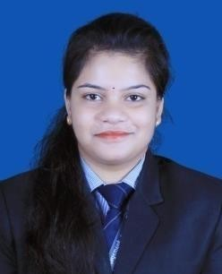
SHUBHANGINI SUBHADARSINI
(Hr Generalist Certified)

Email – shubhanginisubhadarsini97@gmail.com

OBJECTIVE

Secure a responsible career opportunity to fully utilize my training, skills and excellent communication while making a significance contribution to the success of the company.
ACADEMIC PROJECT UNDERTAKEN

Title Of The Project | Organization In Which  Project Is Undertaken | Duration of the Project | Learning Outcome Of The Project
Working Capital Management  practices in NALCO | National Aluminum Company  Limited, Anugul | From 17th June to 31st July ( 45 Days) | - To determine the amount of working Capital Requirement by NALCO.  - To Calculate various ratios relating to working capital .

KEY SKILLS AND COMPETENCIES
- Proactive and able to work deadline.
- Ascertaining Payroll.
- Candidate screening and shortlisiting.
- Need oriented hiring.
- Committed to achieve excellence.
- Treating problems or unexpected event as opportunity to learn.
- Proficiency in talent acquisition

AWARDS AND RECOGNITION

- Won Best Conductor award in the senior group for the year 2012-13.
- Won a Medal for highest mark in F.L. Odia for the year 2012-13.
- Won Best Leader award for the year 2011-12
- Participated in the Personality Development Camp organized by Chinmaya Mission, Dhenkanal in the year 2008.
- Participated in the National Seminar on Frontiers of Digital Finance.

- Participated in the International Conference on Business innovation t
- Participated in Radiance as a role of volunteer organized by SAM, BBSR.
- Won best Presenter Award while publishing a book of Professor of Ravenshaw University, Cuttack in the year 2019-20.
EXPERIENCE

WST TECHNOLOGIES PVT LTD, Noida, Uttarpradesh (18th may 2021 to 18th march 2022)
Designation-HR-Technical Recruiter
- Hands on experience in attracting suitable candidates for open job position for different client (as I am working for different client specifically MNC) and assessing their relevant knowledge experience.
- Expertise in identifying future needs, sourcing candidates through database and portals.
- Conducting interviews and sorting through to fill suit open positions as per assessing applicant’s knowledge, skill and experience.
- Build Infuentional candidate relationships during the selection process.

Suvi Business Ventures, Bangalore, Karnataka (21st March to till the date)
Designation –HR (Team Lead)
-Team leading (Human Resource Management)
-Screening the resumes, sourcing resume using (LinkedIn, cutshort, Hirist, Naukri, Angelist)
-Train the new employee that how to use portal.
-Client Handling.
-well expertise in screening & shortlisiting the suitable candidates for respective requirement.
-Expertise in using various portals like LinkedIn, cutshort, Hirist, Naukri, Angelist.
-Work for various product based company as well as for repudiated company.
- Conducting interviews and sorting through to fill suit open positions as per assessing applicant’s knowledge, skill and experience.

Certification
-HR Generalist certified
-Pro excel certified
-HRBP certified
-LinkedIn IT recruitment certified

IT CREDENTIALS

Proficient in MS Word, PowerPoint and MS Excel
- Internet Savvy
Tally

ACADEMIC DETAILS

Degree/courses | Institute/College | University/Board | Year
MBA | Srusti Academy of Management, BBSR | Biju Pattanaik University of Teleology | 2020
B.Com. | Dhenkanal Autonomous College, Dhenkanal | Utkal University | 2018
+2 Science | Dhenkanal Jr. College, Dhenkanal | CHSE | 2015
10th | S.D. Girls High School | HSE | 2013

INTEREST AREAS & HOBBIES

- Watching Inspirational video
- Playing ludo and carom
- Travelling

STRENGTH

- Positive attitude
- Sincere
- Punctual
- Strong determination

PERSONAL INFORMATION

Address : Jaygopal Sahi, Bajichowk, Dhenkanal Po- Dhenkanal, Pin – 759001
Date of Birth : 11.08.1997
Languages Known : Hindi, Odia, and English Connect : LinkedIn, Gmail
Mob : 7815056489

DECLARATION

I hereby confirm that the above furnished information is true and correct to the best my knowledge and belief.

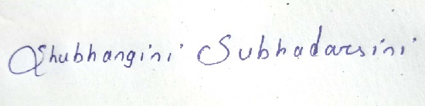
Place: Angul Signature

