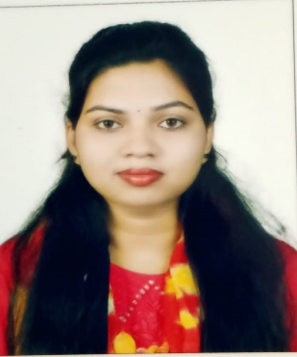
Resume
Name: Arnapurna Nayak
Contact no: +91 9776371083
Email: apnayak19@gmail.com

Objective
Seeking a technically challenging position, to utilize the abilities developed through my Experience and Education with an opportunity for career growth based on my merit and Contributions towards the growth of the organization.

Professional profile
- 2 years of total experience as a Client service executive.
- I am the key account manager for the DP client (signed with DTDC)
- I give direct support to corporate clients over email and call to resolve any shipment related queries.
- Provide regular basis MIS report to the Client and preparing MBR report and resolve client queries.
- Coordination of First mile pickup and last mile delivery of cargo.
- Coordination between operations and customer for timely delivery of cargo.
- I am also preparing report for tracking material pickup and delivery part.
- Handle Corporate Client complaints, provide appropriate solutions and alternatives within the time limits and follow up to ensure resolution.
- Ability to multi-task, prioritize, and manage time effectively.

Key Skill
- Completed MBA post graduate in HR.
- Completed PGDCA Course.
- Microsoft Office Packages: - Word, Excel, Power Point.

Experience Details
- Working at DTDC as Client service executive. (Dec 2022 – Apr 2023).
- Worked at Newateate Pvt Ltd as an Executive. (Jan 2022 – Nov 2022).
- Worked at Cars24 Private Ltd. as Associate Customer executive. (Feb 2021-Dec 2021).

Summary of Skills
- Good communication skills.
- Good relationship with team.
- Positive Attitude towards work.
- Effective communicator with good interpersonal & analytical abilities.
- Effective in working independently and collaboratively in teams and problem-solving skills.

Scholastic
- 2022 MBA from PJ College of Management and Technology.
- 2020 Graduate from Mahila mahavidyalaya Dhenekanal, RD University and Secured 77%.
- 2016 12th from Govt women’s JR College, C.H.S.E. and Secured 61%.
- 2014 10th from Madhusudan Sikshya Nivas School, Odisha State Board, Secured 77%.

Personal Snippets
Name : Arnapurna Nayak.
Father’s Name : Pradeep Kumar Nayak
Gender : Female
Nationality : Indian
Religion : Hindu
Language’s Known : English, Hindi, Odia
Present Address : C-47, Saheed Nagar, Bhubaneswar-751007.

Declaration
I assure you that the details furnished above are true and correct to the best of my knowledge and belief.
Date : Place:

