CURRICULUMVITAE
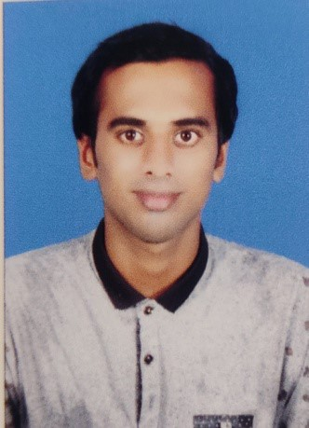

SRIKANTAPANDA
Email:srikanta8637@gmail.com
Contactno-8637246966

CAREEROBJECTIVES
To utilize my skills and knowledge to any organization for the betterment of the company as well as my self & willingness or passionate to learn new things to be come a unique leader or manager & can shape my career in retail operation and management.

EDUCATIONALQUALIFICATION
COURSE | INSTITUTION | YEAR | BOARD
10TH | Saru High school, saru | 2012 | BSE
12TH | KD Science college, pochilima | 2015 | CHSE
BBA | AIMS College ,Berhampur | 2019 | Berhampur university
MBA | Astha school of  Management ,BBSR | Pursuing | BPUT,AICTE  AFFILIATED

WORKEXPRIENCE
Hrct management services- Hr recruiter-6 month
Relience digital- sales excutive-6 month
SUMMER INTERNSHIP

Shopper stop- coustmer care associtated

WORKINGSKILLS
- Client communication
- Sales & market development
- Business development
- Relationship Management
- Team management
- Marketing Campaign management
- Product development
- Brand building strategies

WORKINGSKILLS
MS-WORD
MS-EXCEL
MS-POWERPOINT
STRENGTH
SelfMotivated,HardWorking
HOBBIES
PlayingCricket,ReadingBooks.

PERSONALDETAILS
  - Father's Name- Ramanath Panda
  - Mother's Name-Lili Panda
  - Gender -Male
  - Marital Status-Unmarried
  - DOB-19/05/1997
  - Language Known- Odia, English ,Hindi
  - PermanentAddress-Saru,Hinjilicut,Ganjam,761101
  - State-Odisha

DECLERATION
I Here by declared that above given information is true as per my skills And knowledge.
Date:
Place: (SrikantaPanda)
.

