RESUME

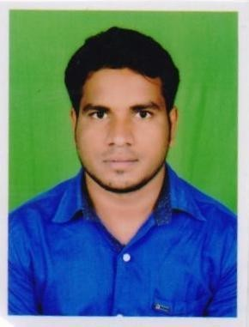JITENDRA NAIK

S/o Late-Jharu Naik, At/po-Turanga
Dist-Angul

Pin-759123(ODISHA)
Contact No: 9040544679

E-mail:jnaik441@gmail.com

Career Objective
To secure a challenging position where, my knowledge and technical skills will be utilized to its fullest potential to achieve the organizational goals.
Work Exeperience
- 2 year experience G.L ( Group leader) sales in Eurekaforbes company.
- 1 year contract basic worked in Tech Mahindra as a customer service executive
Academic Qualification
- DEGREE: Bachelor of Arts(B.A)at Govt.(auto) college Angul (2017) 1st division.

+2(CHSE): Govt jr.college angul (2013) 1st division.

- 10th(HSC) : Mallikeswar high school sankerjang (2011) 2nd division.
Technical Qualification
- Complete PGDCA course in Vedanta Foundation , in year of 2012.

Hobbies

- Playing Cricket
- leaning new skills
- Reading news paper

Personal Details

Name : JITENDRA NAIK
Sex : Male
D.O.B : 17.06.1996
Father’s Name : Late- Jharu Naik
Mother’s Name : Bhanu Naik
Nationality : Indian
Category : SC
Marital Status : Unmarried
Languages known : English, Oriya and Hindi.

DECLARATION

I hereby declare that the above written particulars are true to the best of my knowledge and belief.

Date: SIGNATURE
Place: Angul ( Mr- JITENDRA NAIK )

