
c
v

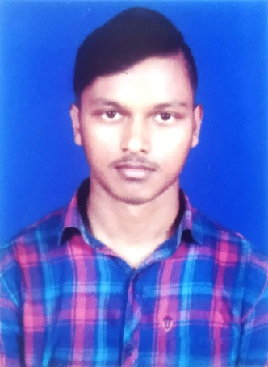

MANOJ BISWAL



AT–NEKUDIKUDA,PO–TALADANDA,DIST–JAGATSINGHPUR,ODISHA,PIN-754141
Mob–6370824224,MAIL–manojbiswal6262@gmail.com

▼ Objective
Looking forward to work for my dream which provides the chance to improve my skills to learn and grow along with the organisationals goals.

▼Education

- Completed HSC examination in the year of 2017 from
  - SRI AUROBINDO SIKSHA SADAN ,TALADANDA with 61%.
- Completed I.COM in the year of 2019 from
  - Adikavi Sarala Das College, Titrol with 71%.
- Completed B.COM in the year of 2022 from
  - Adikavi Sarala Das College, Titrol under Utkal University with 67%.
- Completed PGDCA with Tally from
  - OTEC,Rahama,Jagatsinghpur
    - Grade“A+”

▼Skills
- Quick learner
- Problem solving
- Time management

▼Hobbies
- Listing music
- Travelling

Date-
Signature-

