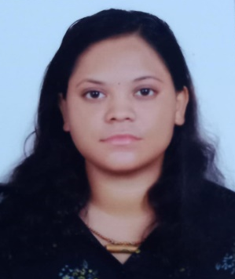
SANTOSINI NAIK
Email : Naiksantosini905@gmail.com
Phone: +91 6371623611
Address: Dalapalanka, Po – Ramchandrapur
Chikiti 761010, Ganjam , Odisha

Objective :
Seeking innovative and challenging career in a growing organization which gives me an opportunity to utilize my skills & knowledge and provides me an opportunity for career growth.

Academic Profile :
- B.Sc in Geology from Chikiti Degree Mahavidyalaya, Chikiti
- 12th from Chikiti Degree Mahavidyalaya , Chikiti
- Matriculation from Rajalaxmi Girls High School, Chikiti
Matriculation | 67.6 %
12th | 54.1 %
B.Sc | CGPA - 7.5

Skills :
- MS Excel, Word, PowerPoint
- Good Communication skills
- Quick learner
Hobbies :
- Book reading
- Creative writing
Personal Information :
Father’s Name : Rabindra Naik
Date of Birth : 3rd February 1999
Gender : Female
Marital Status : Unmarried
Nationality : Indian
Languages Known : Odia, Hindi & English

Declaration :
All the above information is correct up to my knowledge and I bear the responsibility of the correctness.

Place :
Date : ( Santosini Naik )

