CURRICULUM VITAE

SEKHAR SUMAN BEHERA
E-mail: sekharsumanbehera2004@gmail.com
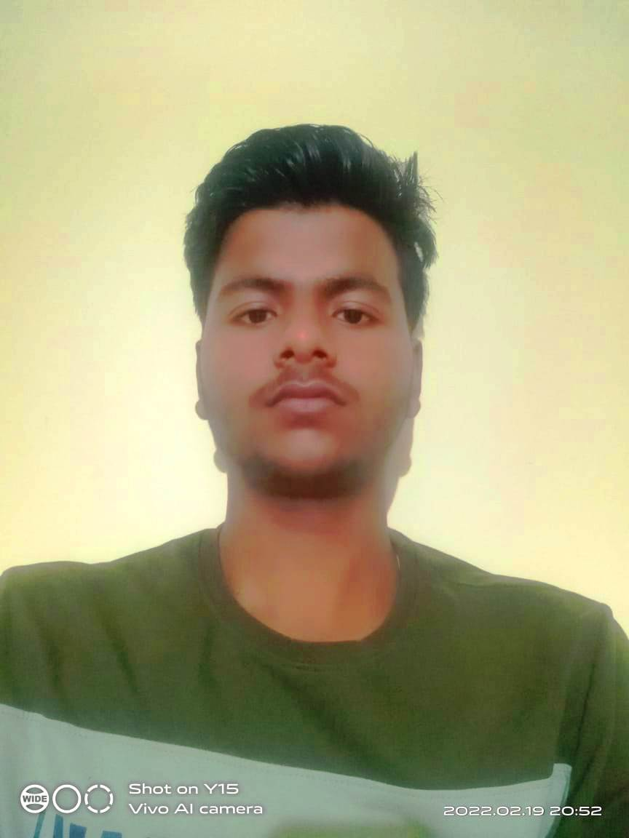
Contact No: (M) +91- 8260924410
AT-BADAMANGRAJ PUR
PO-BIRANILAKANTHAPUR
DIST-KENDRAPARA
PS-DERABISH
PIN CODE-754250

Working Experience
Working as computer experience 1year.

Educational Qualification

 | CLASS/COURSE |  | COLLEGE/INSTITUTE |  | BOARD /UNIVERSITY |  | YEAR OF PASSING |  | % MARKS/CGPA
10th |  | Panchyat high school,kurujanga ,kendrapara |  | Orissa,sudarsan high school, thakurhat |  | 2019 |  | 50%
+2(vocational) |  | Council ofhigher secondary education,odissa |  | C.H.S.E.  ORISSA |  | 2021 |  | 56 %
ADCA (computer) |  | National institute of computer education. |  | NICE |  | 2020 |  | 70%

Computer Knowledge:
MS word, MS Excel, Power Point

Hobbies & Interests
- Drawing & Painting the scenic nature.
- Reading Business Standard, Business Line, Times of India.
- Interest in Sketching.
- Making more friends.

Personal Information

Father’s name : Mr. Ashok Kumar Behera
Sex : Male.
Date of Birth : 16thmarch2004
Nationality : Indian.
Religion : Hinduism.
Languages known : English,Hindi,Odia.
Permanent Address : AT-BADAMANGRAJ PUR
:PO-BIRANILAKANTHAPUR
:DIST-KENDRAPARA
:PS-DERABISH
:PIN CODE-754250
: PH NO-8260924410
Declaration:

I hereby declare that the particulars given herein are true to the best of my knowledge and belief.
Date:
Place: Orissa, India
Signature

