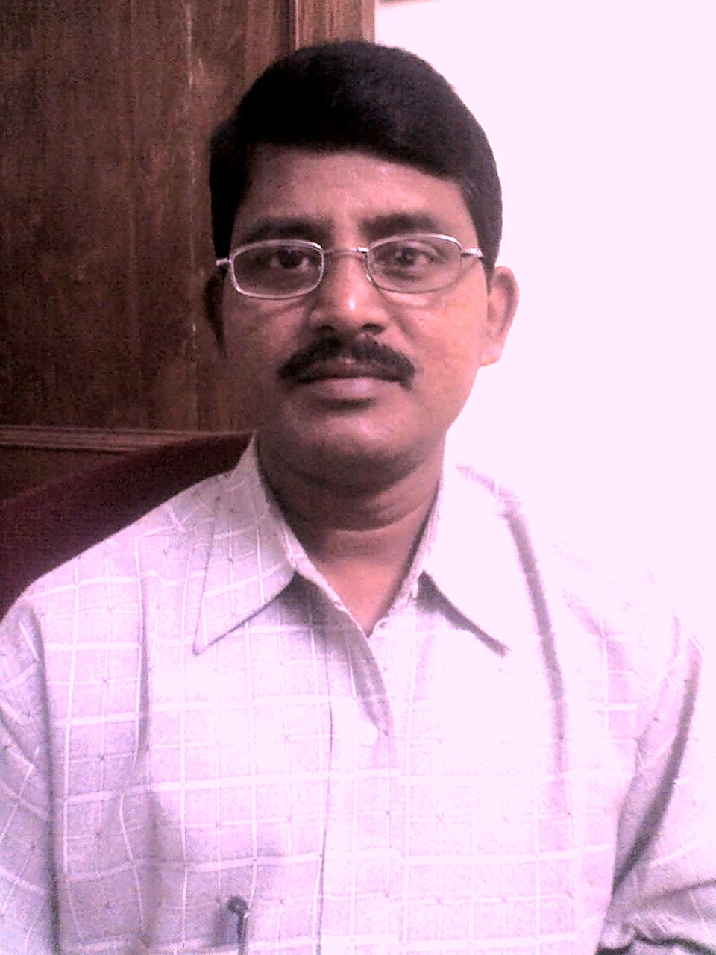
RESUME

Debaraja Sahoo
Mob. No.- 7894420408(M), 8465050783(M)
E-Mail:debaraja_sahoo@yahoo.com / debarajasahoo@gmail.com
Passport No. H 7153749 Dt.04.01.2010 Valid till Dt.03.01.2020

OBJECTIVES

Being a man of commerce faculty with adequate & resourceful experience in Accounts & Finance needs to seek better career opportunities and in the process to assist the prospective organization in the development of system with a great passion, integrity and creativity.

QUALIFICATIONS

ACADEMIC

- M. Com passed in the year 1988 from Ravenshaw College, Cuttack under Utkal University, Vani Vihar, Bhubaneswar, Odisha, India.
- LLB passed in the year 1992 from Madhusudan Law College, Cuttack under Utkal University, Vani Vihar, Bhubaneswar, Odisha, India.

PROFESSIONAL

- ICWAI(Inter) passed in the year 1989 from ICWAI, Calcutta.
- Completed Co-operative Supervisory Training successfully.
- Complete knowledge of computer operation like Accounting package “Tally 6.3, 7.2, ERP 9” SAP and others like Fact, MS Word, Excel, Lotus, Word Perfect and Wordstar.

PERSONAL DETAILS

Name : Debaraja Sahoo

Father’s Name : Dhobi Sahoo

Date of Birth : 1st March 1962

Correspondence Address:a) Room No.20, C/O:GLM Nilayam, Bachupally, Qutbullapur Mandal, Ranagareddy Dist., Hyderabad, Telangana, PIN:500 090.
b) Duplex – 4, Phase–1, Srusti Villa, G G P Colony,
Rasulgarh, Bhubaneswar, Odisha, India,
Pin Code - 751010.

Permanent Address :At-Ratagarh, Po-Sahanga Gopal Pur, Via-Athagarh,
Dist-Cuttack, Odisha, India, Pin Code-754029.

Language Known : Oriya(M.I.L), English, Hindi.

EXPERIENCE

- Presently, working as Sr. Manager (F&A) in Hartex Rubber Pvt Ltd, Hyderabad ( A Bicycle Tyre & Tube Manufacturing & Export Unit) from Nov’12 in its Factory at Bollaram Industrial Estate, Hyderabad looking after Finance & Accounts works maintained in Tally ERP.9 alongwith preparation of CMA Data & Provisional Financials for Bank Working Capital Finance, Liasioning with Banks for daily transactions for timely submission of reports, application for LCs and BGs, yearly renewal of Financial Assistance, and Factory Insurance Matters, maintenance of all statutory records required as per Companies Act’1956 like Fixed asset Register & as per Cost Accounting Record Rules, 2011 for Cost Accounting Records and other statutory matters like Income Tax, Service Tax, TDS, VAT and GST also. Doing Finalisation and Consolidation of Annual Accounts.

- Worked with Lanco Infratech Ltd, Gurgaon from Dec’08 to Nov’12 in its Bargarh Project of Rs.100 Crores & then in its Bhusan Steel Project, Meramandali, Orissa from April’11 with a Project Cost of Rs.700 Crores as Project Finance Head and then in Paradip IOCL Project looking after project accounts maintained through SAP alongwith all statutory matters like Service Tax, TDS, VAT .

- Worked as Accounts Head in M/s. R. C. Metal Industries, a 100% EOU unit in mineral export having the responsibility of maintenance of Accounts upto finalisation, Export & Import job & Taxation (Direct & Indirect Tax), Bank Liasioning job from October 2007 to Dec’08.

- From March 2006 to October 2007, worked in Safa Marine Industries Ltd, Bhubaneswar, a foreign joint-venture company engaged in Fish-net manufacturing with seafood export, working as Sr. Manager (Accounts) doing finalization of accounts, preparation of project proposals for bank finance, reconciliation of accounts with parties & FIs effectively, maintenance & preparation of stocks & looking after day-to-day account works with Taxation ( Direct & Indirect) of the group company as well.

- From December 2004 to Feb ‘2006, worked as Manager (Finance & Accounts) in Konark Aquatics & Exports (P) Ltd, Bhubaneswar, a seafood export Company having EU Certification and it is a deputation from its Parent Company, M/s. Konark Cylinders & Containers (P) Ltd, (a Cylinder manufacturing Company with ISO – 9002 Certification) Bhubaneswar where worked as Manager (Finance & Accounts) since Feb’97 to June 2003 and independently performing the Accounts & Finance job upto finalisation, Excise Works, Sales Tax Works (CST & VAT Act) with entry Tax, ROC Works and also export-import job, DGFT Works in Konark Aquatics.

- From June 2003 to December 2004, worked as Accounts Head in SS Versatech Consummators Pvt Ltd, Bhubaneswar, a residential building construction company performing all accounts jobs upto finalisation and monitoring all receivables & payables.

- From October’92 to Feb’97, worked as Jr. Officer (Accounts) in Indian Metals & Ferro Alloys Ltd (IMFA), a Ferro-Alloys Manufacturing Company, Bhubaneswar in its Raipur Branch, Chhattishgarh performing all the Branch accounts independently including stock maintenance and Branch Sales Tax Works.

- From Oct’90 to Oct’92, as Asst. Manager(Finance & Accounts) in Konark Cylinders & Containers (P) Ltd, Bhubaneswar doing accounts work upto finalisation of accounts with Sales Tax Works.

From Aug’85 to Oct’90, as an Accountant in a transport organization, Mittal Transport, Cuttack and from June’79 to sept’82, as Asst. Secretary in a Co-operative Society, Ratagarh Service Co-operative Society Ltd, Ratagarh, Cuttack.

REMUNERATION : Present Salary –Rs. 8,25,000/- P. A.
Expected Salary – Negotiable .

DECLARATION
I do hereby declare that all the statements furnished herein are true to the best of my knowledge and belief.
Bhubaneswar
Date-18.06.2020 Debaraja Sahoo

