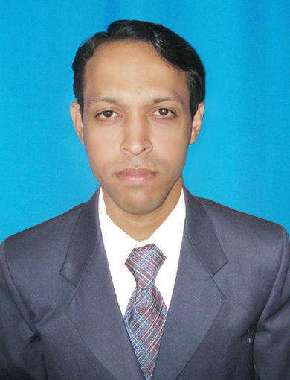

PARSURAM NAYAK
Address:
C/o- Sri Prahallad Nayak
At – Dando,
Po-Kenduapada,
Dist: Bhadrak , State-Odisha
Mob.No-9337466295
E-Mail:- nayak.parsuram08@gmail.com

PROFESSIONAL PROFILE
Dynamic & highly motivated Bachelor of Commerce graduate. Extensive academic & hands-on training & placement with a proven success in organising campus drive for ITI & Diploma candidates with reputed multinational companies across India. Handling all officiating day to day activities prepare work chart etc with an excellent ability to take direction from officers & work independently with minimal oversight. Highly adaptable to challenging environments with an eagerness to advance professional development. Meticulously documents observation in a concise and timely manner with a focus on accuracy.

CAREER FOCUS

- Exposed to all facets of Project Management - Conceptualization, Data Collection, Analysis, Development, Testing and Implementation.
- An enthusiastic professional with ability to plan organize and prioritize workloads to optimize use of resources.
- Experienced in managing and motivating the junior staff to deliver results with the ability to maintain a good team spirit.
- Excellent communication and people management skills that have been honed through association with multi skilled teams.
Academic Qualification:
- +3 Commerce from Sambalpur University, Odisha.
- +2 Commerce from CHSE, Odisha in March 1998.
- Matriculation from BSE, Odisha In April 1995.
Other Qualification:

- GST(Goods & Services Tax) under PMKVY Scheme
  - P.G.D.C.A. from Vinayaka Missions University.
  - Accounts Pro (Tally 9.0)
  - One year commercial type writing, Balangir

EMPLOYMENT SKETCH

- Worked in Tripathy & co.(Chartered Accountant) firm as a Data Entry Operator from 1 Jan 2005 to 31.03.2010.

- Worked in GIFT (Gandhi Institute for Technology) Engineering College as a Data Entry Operator from 14 Aug 2010 to 28 Feb 2011

- Worked under OSCSC Ltd.(Govt.Organisation) as a Jr. Accountant since 14.11.2011 to 30.09.2017.

Presently working at Directorate Of Technical Education And Training
(Govt of Odisha) :- (June’18-Present)

Key Result Areas: Data Entry Operator/ Accountant.

Key Projects: Central Placement Cell, to provide best Jobs for Govt ITI & Diploma Students & Financial assistance to Building & other construction workers scholarship scheme.

Work Responsibilities:

- Responsible to maintain and monitor all the projects status.
- Responsible in establishment of Central Placement Cell for Diploma and ITI students.
- Responsible in liasioning with various companies for the recruitment process.
- Responsible in taking monthly report and work progress of CPC.
- Analysing various Project Proposals been submitted by different organisations.
- Checking attendance of all employees through Biometric Attendance System.
- Giving attendance report and details to the Finance Dept for Salary of Employees.
- All type of office data entry work, entry tax.

Personal Profile:

Name : Parsuram Nayak
Father : Mr. Prahallad Nayak
Date of Birth : 3rd June 1979
Marital Status : Married
Hobbies : Reading Newspaper
Present Address : C/o – Prahallad Nayak
: At – Dando
: Po – Kenduapada
Via-Barikpur
: Dist. – Bhadrak
: State-Odisha

Strength:
- Flexible & Diligent worker.

Declaration

I hereby declare that the above statement furnished in the resume are true and correct to the best of my knowledge & belief.

Date:
Place: Signature

