RESUME
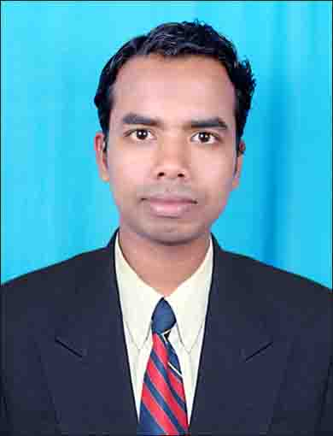

KANGRESS PRADHAN
PLOT NO-46
GOUTAM NAGAR
PO: BJB NAGAR
BHUBANESWAR-751014
Mobile No – 7978874736, 9777398775
E-mail: kangress.pradhan8@gmail.com

OBJECTIVES:

- To work for the organizational goal & profitability where I can increase my knowledge & analytical skill which will provide full for the growth of organization.

- To utilize my ability in corporate sector & give my best to the company.

- To be a part of an esteemed organization for I can where capitalize on my skill, acquire new ones & find opportunity for advancement & as well obtain a copetitive professionally.

EXPERIENCE:

- Working as an Operation Executive in Exide Life Insurance Company since 25th Dec. 2008.
- Worked as a Scanning Executive in Metlife Insurance Company for 6 months.
- Worked as a distributor sales representative in Jk files India Ltd under third party.

Educational Qualification

- Intermediate (12th Standard) in Commerce from Council of Higher Secondary Education, Orissa.

- Graduate in Commerce from Berhampur UniverOrissa.

- CT ( D.EL.ED ) Training completed from Govt. St. School, unit -vi Bhubaneswar.

- OTET Qualified.

Professional Qualification

- M.B.A in Financial Management.

PERSONAL DETAILS
Name | : | Kangress Pradhan
Father's Name | : | Mr. Krushna Chandra Pradhan
Date of Birth | : | 11th June 1987
Sex | : | Male
Marital Status | : | Married
Nationality | : | Indian
Languages Know | : | Oriya, Hindi & English
Hobbies | : | Playing Cricket, Listening Music & Making Friendship
Area of Interest | : | Accounts, Finance, Banking and Insurance
Strength | : | Self-confidence, Punctual, Hard working & Honesty,

Declaration

I hereby declare that all the above information furnished by me is true to the best of my knowledge and belief.

Date- 05-05-2020
Place: Bhubaneswar (Kangress Pradhan)

