CURRICULUM VITAE
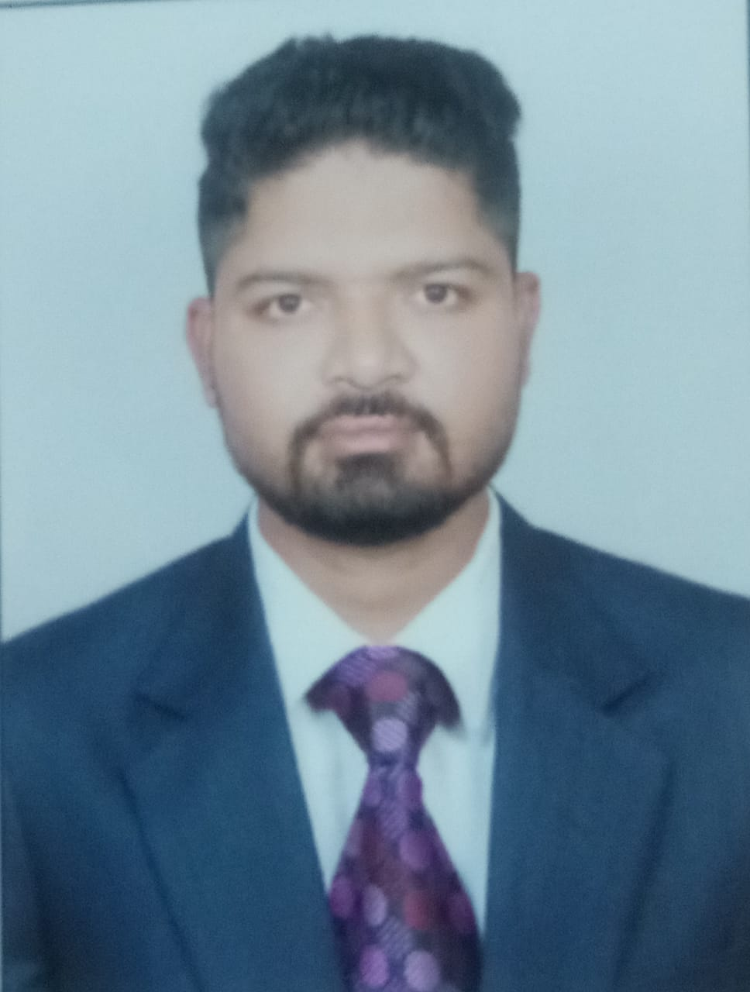
Name  SATYABAN JENA
C/O . Sadananda Jena
Address for Communication:
Qtr. no-1R/3 Stewart school campus,
Unit-8, BBSR,
Pin-751012
Phone No:- 9938226009, 8895440315
E-mail id- satyahenry@gmail.com

OBJECTIVE

To work in a challenging and motivating environment where I can learn more, utilize my technical skills, managerial qualities and broader my vision to a different outlook to the attainment of the organizational goal.
To contribute to the growth of the organization by virtue of my enriching professional skills and expertise.

ACADEMIC QUALIFICATIONS

2008 10TH from Stewart school BBSR under ICSE
2010 +2 in science stream from Rajdhani college, BBSR under CHSE
2017 +3 in Science stream [BSC] from Rayagada Autonomous College, Rayagada
EXTRA QUALIFICATION
- PGDCA(post graduate diploma in compute application) from CAC,BBSR
- 6 month free pharmacy course from DR.REDDY,BBSR

WORKING EXPERIENCE

- Maruti automobiles 1year experience as a maintenance manager
- APOLLO PHARMACY 2 year experience as a pharmacist, BBSR
- BIOPHAR PHARMA 3 year running as a medicine Representative(MR),BBSR

PERSONAL INFORMATION

Date of Birth : 08.08.1991
Gender : Male
Marital Status : Unmarried
Permanent Address : At/po- Narayanpur, Ps-Digaphandi, Dist-Ganjam,
pin - 761012
Language Known : English, Hindi, Odia
Hobbies & Interest : Reading newspaper, listening music
Impart teaching, watching reality shows on TV etc.

DECLARATION

I hereby declare that all the information furnished by me are true to the best of my knowledge and belief.

Date: 13.12.19 Satyaban Jena
Place: Bhubaneswar Signature of Candidate

