CURRICULUM VITAE
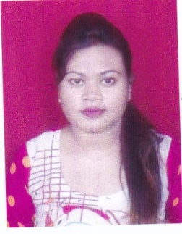
Purnima Bhowmick
Telephone (M) – 9131270394
E-mail - purnimabhowmick92@gmail.com

CAREER OBJECTIVE
To be an integral part of a progressive organization that will provide me a learning environment so that I can endow my skill and knowledge for the mutual progress.
PERSONAL INFORMATION
Date of Birth | 26th October, 1996
Place and Country of Birth | Korba, Chhattisgarh, India
Gender (M/F) | Female
Present Citizen | Indian
Permanent Address | D/O: Mr. Lalu Bhowmick, H/No. 52 Gandhi Chowk Sunar Gali, Korba Chhattisgarh, 495677
Current Address | D/O: Mr. Lalu Bhowmick, H/No. 52 Gandhi Chowk Sunar Gali, Korba Chhattisgarh, 495677
Language | English, Hindi, Bengali
ACADEMIC DETAILS
Course | Percentage(%) | Name of the School/College
Bachelor of Commerce | 58.4% | Kamla Nehru College, Korba, Chhattisgarh
12th HSSC | 67% | St. Xaviers Public School, Korba (C.G)
10th HSSC | 5.4 CGPA | St. Xaviers Public School, Korba (C.G)

SOFTWARE SKILLS
Microsoft Office : (Power Point, Word, Excel)
Operating System: Window XP, Window 7
KEY STRENGTH
- Honest
- Good Listener
- Hard Worker
- Self-Motivated
- Conflicts Handling
- Eager to learn new things

