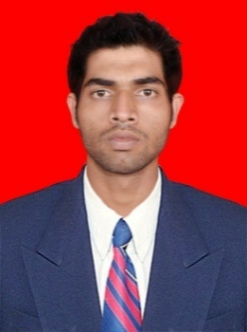
SANDIP KUMAR MOHAPATRA
Contact No.: +917978625563
Email ID: sandipmohapatra11@gmail.com

______________________________________________________________________
Career Objective:
- To excel in my career by working sincerely and dedicatedly.
- To work for the benefits of organizational growth by use of the best of my skills and hard work.

Educational Qualifications:
Sl.No. | Course | Specialization/ stream | College/  School Name | University/  Board | Year of  Passing | Percentage/  CGPA
1 | MBA | FIN & MKT | USBM, Bhubaneswar | BPUT | 2016 | 76%
2 | BBA | BBA | IMAGE | Utkal University | 2014 | 59%
3 | Intermediate | Commerce | PN college Bhubaneswar | CHSE | 2011 | 44%
4 | Matriculation | General | PADMABATI UCHA BIDYAPITHA | BSE | 2009 | 68%
Projects:
Summer Internships (MBA) Company Name- BhSE(BHUBANESWAR STOCK EXCHANGE)
Place-Bhubaneswar DuRation-1 month Project Topic- DEMATERIALISATION A SHARE VANISHING TRICK(FINANCE)

Summer Internships (BBA)
Company Name:-PANTALOON
Place:-BHUBANSEWAR
Duration:-1 MONTHS
Project Topic:-THE STUDY OF CONSUMER BEHAVIOUR AT PANTALOONS RETAIL LIMITED(MARKETING)
Technological Knowledge:
PGDCA (UK COMPUTER POINT (PURI) 2012)

Personal Strengths:
- Punctual and well –organized approach.
- Good at dealing with people.
Experience:- 3 years 6 months
Work in Nexa Twincity As a Finance executive 1 year(RETAIL CAR LOAN SALES)
Work in Shriram General insurance pvt Ltd as a sales executive more than 1 year ( GENERAL INSURANCE SALES IN AGENT VERTICAL CHANNEL)
Work with Intendem solutions Pvt Ltd as a Team leader (Loan application sales in mall channel)
Presently working with Sbi credit card as a senior sales executive (mall channel)
Hobbies:
1. Listening Music.
2. Watching Cricket match
3. Playing pc games
Personal Details:
- Father’s Name: Sangram keshari mohapatra
- Date of Birth: 23/04/1994
- Permanent Address: AT/PO:-MANGALPUR,PS-PIPILI, DIST:-PURI
- Languages known: English, Hindi & Odia.
Place: Bhubaneswar Sandip Kumar Mohapatra
Date:

