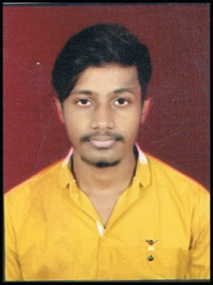
Pranoy Acharya
Mobile No :- 9131575595
E-mail ID: - pranoy.great04@gmail.com
CAREER OBJECTIVE: -
Seeking an opportunity in a financial organization that can enhance my skills.
ACADEMIC QUALIFICATIONS: -
Course | Institution | Board / University | Medium | Year of completion | Percentage
Bcom 2nd year | St. Vincent Pallotti College | Pandit Ravishankar University | English | 2019 | 64%
Bcom 1st Year | St. Vincent Pallotti College | Pandit Ravishankar University | English | 2018 | 50.83%
12th | Holy Cross Sen. Sec. School, Byron Bazaar | CBSE | English | 2017 | 67.6%
10th | Holy Cross Sen. Sec. School, Byron Bazaar | CBSE | English | 2015 | 79.86%

COMPUTER KNOWLEDGE: -
- Basic Knowledge
- Tally
- MS-OFFICE
- Internet
WORK EXPERIENCE :-
- Worked for three months as article trainee in a CA Firm (CA NIHAL JAIN & CO. ) from 12 AUG’19 to 12 NOV’19
- Worked as an Assistant Manager in The Tastemakers (Cafe Junoon ) from 15 NOV’19 to 15 FEB’20
STRENGTH :-
- Hard Working
- Positive attitude towards learning new things, creative.
WEAKNESS :-
- Believe in doing work with perfection even if it’s time consuming.
- Straightforward

ACHIEVEMENTS AND EXTRA CURRICULAR ACTIVITIES:-
- Won first prize in creative writing competition.
- Won 2nd prize in inter class assembly competition.
- Got certificate for excellent performance in academics.
WORKSHOPS AND SEMINARS ATTENDED:-
- Attended Cyber Security and Web Entrepreneurship Workshop conducted by NEUROMENCERS.
PERSONAL PROFILE:-
- Father’s Name : Tanmaya Acharya
- Date Of Birth : 02/02/1999
- Gender : Male
- Marital Status : Unmarried
- Nationality : Indian
- Languages Known : Hindi & English (Read, Write, Speak)
- Address : Qno:48, Amey Vihar Coloney, Near Shakti dham, Gali no: 7,
Telibandha Raipur (C.G)
- Hobbies : Writing , Reading .
- Pin code : 492006
DECLARATION: -
I do hereby declare that the above information is true as per my knowledge.
Date : ……………...
Place : Raipur Pranoy Acharya

