RESUME  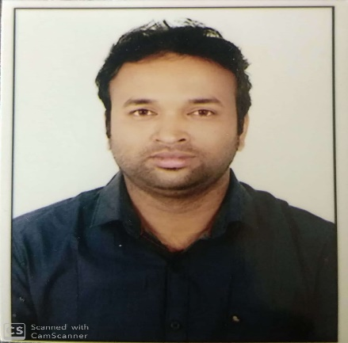  Name:Asit Kumar Sahoo  Mob: 99388 67156  Present address:  Asit Kumar Sahoo  S/o: Mr. Naba Kishore Sahoo  Near Ganapati Yuva Parishada, At: Modern India,  Fertilizer Township,  Po: Rourkela-07,  Dist: Sundergarh, Orissa  Mobile: 99388 67156  E-mail id:  asitkumar.sahoo156@gmail.com  mail.asit@rediffmail.com  Personal Data:  Date of Birth : 10th June 1986  Gender : Male  Nationality : Indian  Caste : General  Marital Status: Married  Fathers Name: Naba Kishore Sahoo  Languages: English, Oriya,& Hindi  Interests: playing cricket, Listening music. | Post Applied for: CREDIT MANAGER / AREA CREDIT MANAGER  Location: Odisha  Mob: 99388 67156  Resume Headline:  8 years CREDIT experience in two Banks & two NBFC. Experience in Individual loan, Business loan, Personal loan, Term loan, CC loan, Home improvement loan, TW loan, Refinance etc. Now Handling 12 branches with 4 Credit Analyst in Odisha.  Work Experience  - Working as a post of CREDIT MANAGER-ODISHA (Team Size - 4) in SAMBANDH FINSERVE PVT LTD (Individual Loan, Business Loan & HIL) from Nov 2019 to till now.  - Worked in BANDHAN BANK LTD (SME) Below 10 Lakhs as a post of CREDIT MANAGER from Sept 2018 to Nov 2019.  - Worked in ANNAPURNA FINANCE PVT LTD (MSME) as a post of CREDIT MANAGER from June 2017 to Sept 2018.  - Credit experience with INDUSIND BANK LTD, (CFD) as a post of CREDIT VERIFICATION OFFICER from July 2010 to June 2017.  Job Profile  - As Credit Manager (Odisha):  - Responsible for handling 4 Credit Analyst in 12 branches in Odisha & taking decision individually as well as credit & risk control of both MBL & HIL cases.  - Educate & training to all credit members to take care of above activities and also make them understood system & audit coordination.  - To help the cluster achieve overall budgeted numbers (Portfolio, NPA and Profitability).  - Requires to travel branches 2 days in a month across the branches.  - If requires it needs to stay overnight at the branch location.  - Maintaining record of all branches daily basis & send monthly report to COO before 5th of every month.  - As Credit Manager: Responsible for PD, Credit Appraisal, Risk control, decision making, documents verification, client selection, legal documentations, disbursement, general office administration, timely reporting fraud & irregularities, prompt customer services etc.  Location: Rourkela, Sundergarh, Jharsuguda, Sambalpur, Bargarh, Balangir, Angul, Talcher, Khurdha, Bhubaneswar etc  - As CVO: Responsible for credit screening, decision making and evaluation of TW, PL & Re-finance, taking prior approval from product head & state head, documents verification, Ensure FI documentation & policy compliance before issuing DO, finalization of scheme, making dealer payments, Checking worksheets before sending to CO, Timely reporting of irregularities and frauds, follow up for collection of post disbursement documentation, job included monitoring banking and collection activities and general office administration, ensuring prompt customer service, Checking Pre-closures & issuance of NOC, Profitability analysis & working on increasing branch profits.  Academic Qualification  2000 – 2001 (Matriculation under BSE, Cuttack, Orissa)  2001 – 2003 (I.Com under CHSE, Bhubaneswar, Orissa)  2003 – 2006 (B.Com with distinction under Sambalpur University)  2012- (MBA FIN-HR under Sambalpur University)  Professional Qualification  - 1 Year PGDCA from ASCENT INFOTECH, Rourkela  - Tally 7.2 & 9.0 from UNITECH Computer Centre, Rourkela.  Computer Skill  Working knowledge in Internet, Windows, FoxPro, MS office, PowerPoint, Photo shop, Corel Draw etc.  Operated: HP LaserJet 1010, hp Scan jet 2400, Printer M200  Personal Competencies  - Work effectively with diverse groups of people  - Friendly with an upbeat attitude  - Committed to deadlines and schedules  - Honest, Sincere and a Hard Worker with a high level of integrity  Declaration  I am confident of my ability to work in a team. I hereby declare that the information furnished above is true to the best of my knowledge  Place: Rourkela (Odisha) Asit Kumar Sahoo

