USHA KHANDELWALMBA, HUMAN RESOURCES& Marketing  An HR Professional seeking a position in a Growth oriented Firm, where she can follow both her passions of life, Personal Growth & Service to Humanity . | PERMANENT ADDRESS  HARISH CHANDRA ROUT  Mandal Bagicha, HemakapadaChhack, Sunhat, Balasore , 756002  Mobile:+918249818885  +919438264342  Email: gudiausha46@gmail.com
SUMMARY OF QUALIFICATION  - Proficient in Handling Recruitment Process from basic level of sorting the application to final selection process.  - Capable of Identifying the core Requirements of a Job and match it with Profiles for suitable skills and experience.  - Skilled in Planning & implementation of Employees Motivational Events, gather feedback about satisfaction and apprise the authorities about it, within time & budget.  - A Clear & Dynamic Communicator. Capable of presenting Assigned Task to Diverse Audiences and convey the objectives in clear cut terms  - Known for building strong relationship with both external and internal parties  ACADEMIC PROJECT & INTERNSHIP  MARKETING STRATEGY OF GODREJ—MBA  The marketing Strategy is a crucial tool to help understand what the product and services can offer and how to plan for a successful product offering.  EXPERIENCE  Star Health & Allied Insurance Co LTD,Balasore— Agency Development Manager  September,2019 (Continue…)  Role:  Interact with Customers to understand their need and help maintain relationship for the longer and better Customer Lifetime Value. Responsible for Upselling, Repeat Purchase & Retention of the existing customers. Also apprising the management about Problem areas and grievances and help them in troubleshooting.  EDUCATION  Modern Engineering and Management Studies,BLS,BPUT — MBA ( HR & Marketing),  (COMPLETED IN 2017)  Fakir Mohan (AUTO) College,BLS— B.COM  (COMPLETED IN 2012)  Fakir Mohan Junior College,BLS  (COMPLETED IN 2008)  Barabati Girl’s HighSchool,BLS — HSE  (COMPLETED IN 2006)  PERSONAL PROFILE  Name —Usha Khandelwal  Father’s Name —Mr. Kishore Khandelwal  Date of Birth — 08/08/1990  Marital Status -Married  Nationality — Indian | 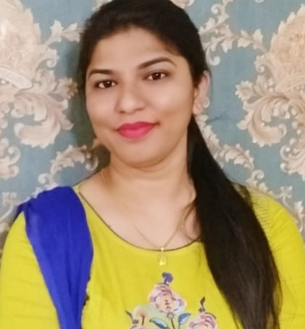  SKILLS  - Human Resource Development  - Training Need Assessment  - Working knowledge of Computer  - Team Management  - Hiring & Profiling Techniques.  - Internal & External Coordination  - Management of Motivational Event & Corporate Meetings  - Trainings  Software Skills  MS OFFICE  Hobbies/Interest  - Reading  - Cooking  - Music  - Travel  Languages:  - English  - Hindi  - Oriya

