RESUME
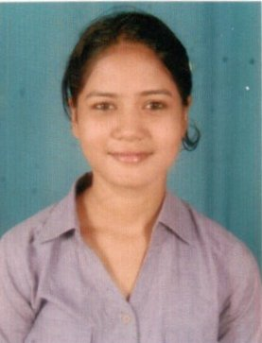

URMILA PRADHAN

D/O-Prafulla Kumar Pradhan

At/Po-Satyabhamapur

P.S- Jagatpur

Dist-Cuttack

Pin-754200

Mob : 8763868918 / 6372795700

Email - urmilapradhan7274@gmail.com

Personal Objective:
To obtain an Electrical Engineer position with company to use degree in electrical engineering and experience with troubleshooting problem area in various electrical systems.
Academic Qualifications:
Qualification | Stream | Institute | Board/University | Year | Aggregate%/CGPA
GRADUATION | ELECTRICAL | VEER SURENDRA SAI UNIVERSITY OF TECHNOLOGY (Formerly UCE),  BURLA | DEEMED UNIVERSITY | 2018 | 7.22
DIPLOMA | ELECTRICAL | BHUBANANANDA ORISSA SCHOOL OF ENGINEERING, CTC | SCTE&VT,ODISHA | 2015 | 81
MATRICULATION |  | GOPINATHPUR HIGH SCHOOL | BSE, ODISHA | 2012 | 89.5

Training and Project :
Training in Odisha Power Transmission Corporation limited (OPTCL)
Strength and Interest:
STRENGTH:
- Hard working & punctuality.
- Ability to take responsibility.
- Ability to deal with people diplomatically and to work in a team.
EXPERIENCE:
- Six month experience in Load share Logistic Network BBSR.
INTEREST:
- Reading stories, novel.
- Learning new things.
- Listen to music.
- Cooking.
Personal Information:
Name : Urmila Pradhan
Father’s name : Prafulla Kumar Pradhan
Permanent Address : At/Po-Satyabhamapur
P.S- Jagatpur
Dist-Cuttack,Odisha
Date of Birth : 14th Feb 1997
Nationality : Indian
Religion : Hindu
Sex : Female
Caste : GEN
Language Known : Odia, Hindi & English
Declaration:
I , Urmila Pradhan ,hereby declare that the above written particulars are true and correct to the best of my knowledge and belief.

PLACE:

DATE : (URMILA PRADHAN)

