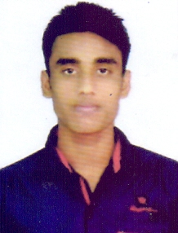
RESUME
POST Applied For : Job Seeker
Rasmikant Mohapatra
At : Chhotanathapur Sasan
Po : Sitaleswar
Ps : Aul
Dist-Kendrapara
Pin-754219
Mob-8658031599
Email:rasmikanta999@gmail.com

CAREER OBJECTIVE
For seeking a long term-career in a diversified and dynamic organization that provide opportunities and challenge for career development. To pursue an evolving career with an organization, which provides ample scope for my knowledge and skills that would fetch me success and better out puts for the organization.

STRENGTHS:
- Hardworking
- Effective Time Management
- Punctuality, Capability, Adverse situation handling.
- Positive thinking, Believe in teamwork.
- An ever-learning attitude
Specific Skills
- Communication Skill
- Interpersonal skill
- Presentation skill
- Active listening skill
- Punctual with time management skill

EDUCATION QUALIFICATION:
Exam passed | Board/University | Year of passing | Division | Percentage
10th | BSE Odisha | 2013 | 1st | 67.66
+2 COM | CHSE Odisha | 2015 | 2nd | 52.50
+3 Com  (Acct Hons) | Utkal university | 2018 | 1st | 62.50
MBA | BPUT | Continue | 1st | 78%(1st Yr)

COMPUTER SKILLS:
- Tally erp9.0
- PGDCA
LANGUAGE KNOWN:
- Odia, Hindi, English.
Co-scolastic Activity:
- NCC-Senior Under Officer, Odisha
- Sports : Taekwondo
PERSONAL DETAIL:
Name : Rasmikanta Mohapatra
Father’s Name : Mr. Ratikanta Mohapatra
Date of Birth : 02.06.1998
Sex : Male
Marital status : Unmarried
Nationality : Indian
Religion : Hindu
Declaration
I do hereby declare that all the above mentioned information which is furnished is true & accurate to my best of knowledge and belief.

Place:-
Date:-
Rasmikant Mohapatra

