RESUME 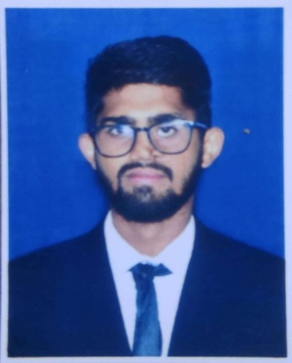

NAME:-RAJESWAR MAHAPATRA

CAREER OBJECTIVE
To be a part of an organization where get a chance to use my knowledge and skills to contribute in the progress of the organization and myself to achieve the goals of the company and customer satisfaction and experience I utilize my interpersonal skills.

EDUCATIONAL QUALIFICATION
Sno. | Board | Degree | Institution | Year | %/CGPA
01. | BSE | High School  (X Std) | Raghunath Bidyapitha,Odagaon | 2014 | 65%
02. | CHSE | Intermediate  (XII) | Raghunath Samabaya Mahavidyalaya,Odagaon | 2016 | 66%
03. | ODISHA | Graduation  (B.SC) | Model Degree college,Nayagarh | 2019 | 7.50
04. | ODISHA | MBA  (Marketing &Finance) | Amity Global Business School,Bhubaneswar | 2019-21 | 8.88

SKILL SETS:-
- Technical skills- MS Word, MS Excel, Power Point.
- Soft skills –Good Presentation skills, Confident, communication skill.
- Operating System- Windows 7,8,10 etc.
- Completed PGDCA from certified institution.
INTERNSHIP:-
- SIS securities(India) Pvt. Ltd
DURATION- May/2019-june/2019

- Role and responsibilities:-
- I was selling the COVID-19 related product (fever check gun, face recognition attendance system)
- Calling to different customer and then promote your product and service (Securities, Manpower etc.).
- Generate the lead from them.
- Also calling existing customer
- Measure the customer satisfaction level.

STRENGTHS:-
- Hard working
- Seriousness
- Traded with unexpected situation
- Time management

HOBBIES:-
- Teaching children
- Listening music
ACHIEVEMENTS:-
- Got A grade marks in PG diploma application in 2014.
- I have in merit list or got the certificate in world ozone day quiz competition.
- Got first prize in marketing fest at amity, Bhubaneswar.
- Got prize in HR competition at amity, Bhubaneswar.
- I have monitored the class in the school and college level.
- I have topped in our bachelor degree of last 5th and 6th semester.
LANGUAGE KNOWN:-
- English,Hindi,French and Odia

PERSONAL DETAILS:-
Date of birth: 03-06-1999
Address: At-khelapadia sahi, Po-odagaon, Dist-Nayagarh, Odisha, Pin-752081
Fathers name-Pabitra kumar mahapatra
Contact No-8637282596
E-Mail ID-rsmahapatra99@gmail.com

