CURRICULAM VITAE
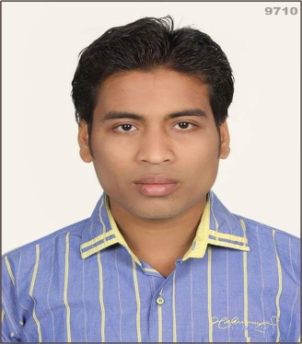

KANHU CHARAN GURU
Email:kanhu.guru@gmail.com
Mob : 9658992768, 7008350114

- Career Objective :

- To be a part of result oriented profession team that provides a challenging innovative work environment & opportunities for career & personal development.
- Work Experience :

- Worked as a Sales Executive at HIPPO NAMKEEN in Balangir District and kesinga from 3rd Feb 2018 to 25st SEP 2019.

- Educational Qualification :

Degree | Board/University | Year of Passing | Percentage(Div)
HSC | B.S.E, ORISSA | 2007 | 56.8%
+2 Arts | CHSE ORISSA | 2009 | 35%
BCA | PUNJAB UNIVERSITY | 2012 | 67.95%

- Computer Knowledge :

- Bachelor in Computer Application

- Personal Details :

- Father's Name : Ashok Kumar Guru
- Language Known : English, Hindi & Odiya.
- Date of Birth : 01 May 1992
- Nationality : Indian.
- Religion: : Hindu
- Hobby : Listening Music, Internet Surfing.
- Marital Status : Single.

- Permanent Address :

- Name : Kanhu Charan Guru
- At : Brahmin Para
- P.O. : Balangir
- P.S. : Balangir
- Dist : Balangir
- State : Odisha
- Pin : 767001

- Declaration :

I Kanhu Charan Guru affirm that the information given in this application given by me are true and to the best of my knowledge. I also fully understand that if at any stage it is discovered that any attempt has been made by me to willfully misrepresent the facts, my candidature may be summarily rejected.

Date:-
Place: - Balangir KANHU CHARAN GURU

