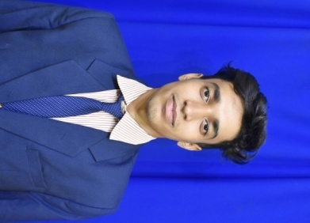
RESUME

Name – Siddhartha Sekhar
Branch –mechanical engineering
Phone: 7205341116
E-mail:- sidsekhar1234@gmail.com

CAREER OBJECTIVE

To make a sound position in corporate world and enthusiastically in team to achieve goal of organization with devotion and hard work.
EDUCATION

- B.Tech. in Mechanical Engineering with CGPA-7.19 at Gandhi Institute of Engineering and Technology, Affiliated to Biju Pattnaik University of Technology, Orissa.

- Completed (+2 Science) from Newton college of+2 science, sambalpur, Odisha having 67.3% .

- Passed 10th class from Saraswati Vidya Mandir ,dhanupali , Odisha,
Affiliated to Board of Secondary Education, Odisha in 2010 having 80.10%.

TRAINING AND PROJECT

- One month summer training programme :
- In Assembly Shop, HAL, Koraput (Odisha).
- In Hindalco, Sambalpur (Odisha).

- Project Work :
- Successfully completed project on “Gear design and manufacturing” in HAL Koraput Division.
- Successfully completed a project on solar power grass cutter
- Successfully completed the fabrication and assembly of an “Electric GO-Kart”.
- Completed one day workshop on 3-D printing at CTTC Rayagada.
- Successfully completed B.Tech final year project on “Structural Analysis of Composite Structures.”

SOFTWARE EXPOSURE

- Programming Languages: ‘C ‘.
- Equipped with
- Software : Microsoft Office 2013, Auto CAD 6,Catia V5 R19
- Operating System: XP, Windows Vista, Windows 7, Windows 8, Windows 10, Ubuntu.

ACHIEVEMENTS

- Won the intra college mobile gaming on “Mini Militia” and “PUBG”.
- Won the Intra College Cricket Tournament 2018.

CO-CURRICULAR ACTIVITIES
- Member of College cricket Team, GIET, Gunupur.
- Member of Mesa Club, GIET, Gunupur.

HOBBIES

- Playing Cricket
- Watching movies and series
- Internet Surfing
- Computer Games(adventurous)

PERSONAL DATA

Date of Birth : 30.11.1998
Gender : male
Father’s name : Chakanan Mishra
Nationality : India
Languages : Odia, Hindi, English
Permanent address : Ml-10,Mahabir Para, Dhanupali, Sambalpur,Odisha

Date:
Place: GIET University, Gunupur full signature

