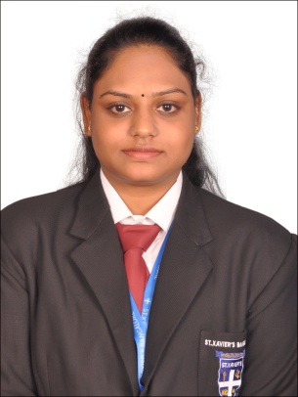
RESUME

Name: CELESTI EKKA
Address: 311 Subham Green near Tresaure Fantacy
Indore (MP) Pin-453331
E-Mail Id: celestijohn1995@gmail.com
Contact No.: 7899593075
----------------------------------------------------------------------------------------

Career Objective:

"To succeed in an environment of growth and excellence and earn a job which provides me job satisfaction and self-development and helps me achieve personal as well as organizational goals".

Educational Qualifications:

- Master of Business Administration
(Marketing and Banking Finance)
Bangalore University 2018-2020

- Stenography
ITI Indore (MP) 2016-2017

- Bachelor Of commerce with taxation
DAVV University Indore (MP) 2013 -2016

- 12TH
Alpine Public School Indore (MP) 2011-2012

- 10th
IPVM School Indore (MP) 2010-2011

Work Experience:

- Sales Executive
BookSquirrel Publication House Indore (MP)
(INTERNSHIP )

- Sales Trainer
Synture Indore (MP)

Academic Project:

- A project on “ORGANISATION STUDY AT BOOKSQUIRREL PUBLICATION HOUSE” Indore

- A project on “RISK MANAGEMENT IN INDIAN BANKING SECTOR”

Industrial Visit:

- Visit to Ashok Leyland, Hosur

- Visit to Toyota Kirloskar

Certification:

- Advanced Excel

- Knowledge in MS. Excel,MS.Word and basic operation.

Skills and Strength:

- Strong work ethics

- Team work ability

- Time management

- Positive attitude

Achievements:

- Got 2nd price in 200 meter race

- Runner up in Relay race.

Personal Details:

- Date of Birth: 19/02/1996

- Languages known: English, Hindi

- Hobbies: Listening to music, Watching movies

- Marital Status: Single

- Nationality: Indian

Declaration

I do hereby declare that above particulars of information and facts stated are true, correct and complete to the best of my knowledge and belief.

Date:
Signature
Place:

