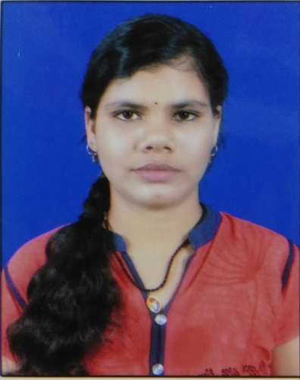
SAGARIKA NAYAK

Address:-
At: Gangadharpur ,Jaraka
Dist: Jajpur, Odisha
Pin: 755050
Email id: sagarikanayak943@gmail.com
Mobile no: 9439121137

Career Objective

To work in an organization where I can utilize and apply my knowledge, skills which would enable me as a fresh graduate to grow while fulfilling organizational goals.

Academic Qualification

 | Degree / Qualification | Institute | Board / University | Year | Aggregate  % / CGPA
 | MBA | CIME | BPUT | 2020 | -
 | Graduation  (B.COM) | B.B. Mohavidyalaya,  Chandikhole | Utkal University | 2017 | 63.5%
 | +2 commerce | Dharmasala Mahavidyalaya,  Dharmasala | CHSE | 2014 | 60%
 | Matriculation(10th) | Patitapaban  High School,  Gangadharpur | HSE | 2012 | 63%

Professional Proficiencies

- Computer : PGDCA

Self Assessment:

- Good listener
- Hard working

Hobbies:

- Dancing
- Listening to music

Strength:

- I am not emotional
- I don’t easily believe people

Weakness:

- I am little introvert

Personal Details

Father’s name: Mr. Brahmananda Nayak

Date of Birth : 05/05/1997
- Gender : Female

Blood Group : B +ve
- Languages known: English, Hindi, Odia

Declaration

I hereby, declare that the information furnished above is true to the best of my
Knowledge.

DATE: 8th April,2019 SAGARIKA NAYAK
knowledge.

