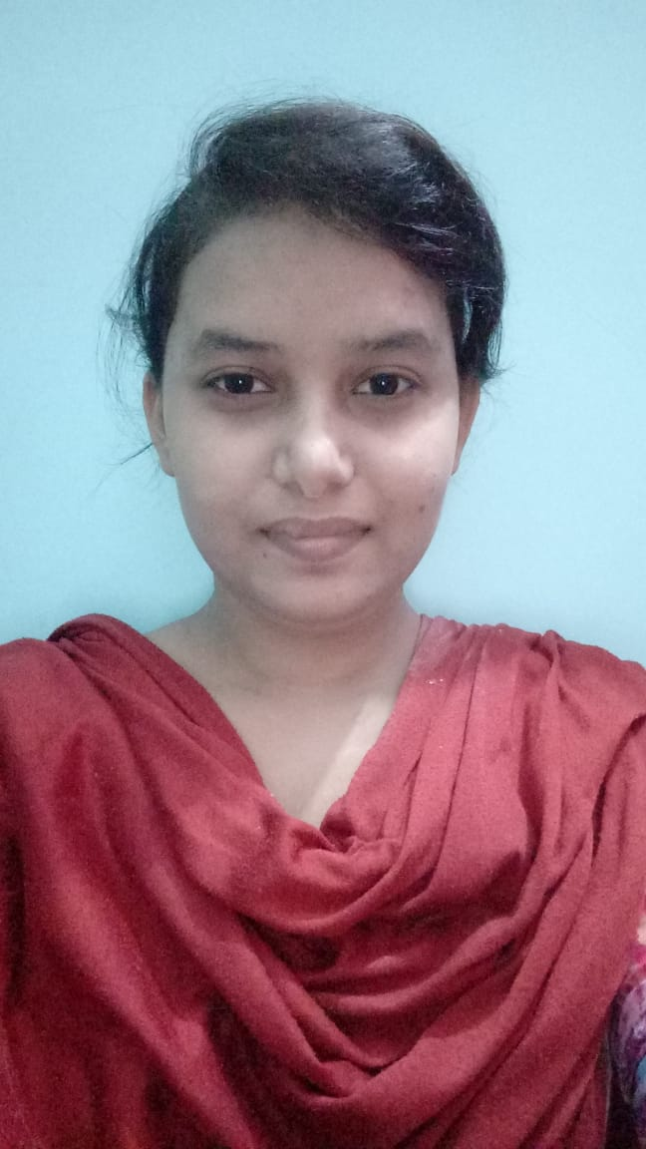
CURRICULUM VITAE

ROSY KHATUN

Mobile No: 9583586499

Mailing Address:  D/O – MD CHAND ANSARI  At- MASJIDPARA  Po – SUNDARGARH  Dist – SUNDARGARH  Pin - 770001  Odisha.  Permanent Address  At- MASJIDPARA  Po – SUNDARGARH  Dist – SUNDARGARH  Pin – 770001  Odisha  Email:sohaibmohammad109@gmail.com | Summary (CAREER OBJECTIVE)  Being a strong believer in sincere & hard work, I am looking forward to a challenging, growth oriented job where I can effectively contribute my skills, abilities and my total effort possessing competent technical skills.  I possess strong work ethics and willingness to work hard to achieve employers and personal objectives. I am a strong team player with excellent interpersonal and communication skills.  Academic Qualification  - Completed Higher Secondary Board in Arts from Sundargarh Govt Junior College, Sundargarh under Council of Higher Secondary Education , Odisha with average of 42% of marks in the year 2016.  - Matriculation from Govt Girls High School, Sundargarh , Sundargarh with 52% of marks under Board of Secondary Education in the year 2013.
My Strengths
- Positive approach.
- Efficient team player.
- Ability to learn.
- Good analyzing skills.
- Proactive and dedicated toward my work.

Personal details
Father's Name : Md Chand Ansari
Mother's Name : Naimul Khatun
Date of Birth : 16th MAY 1997.
Nationality : Indian
Gender : Female
Marital Status : Single
Languages Known : Hindi, English, Oriya
Hobbies : Singing, Reading,Swimming

Declaration:

I hereby declare that the above particulars are true to the best of my knowledge and belief.

