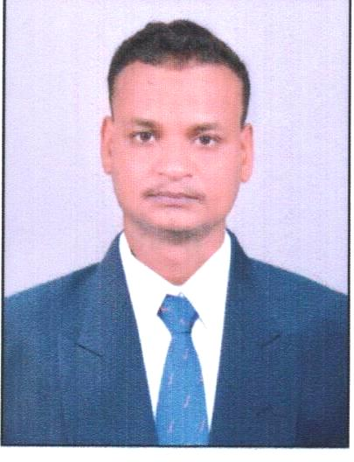
RESUME
TUNA SAHU
C/O:- NABIN SAHU
AT:-RAMBHIPALI PO:-KHANDAHATA PS:-SUBALAYA
DIST:-SONEPUR
Odisha 767018
Mob. No:- +91 7894952506, 9078062759
Email:-umakantsahu01@gmail.com

OBJECTIVE:-
Intend to build on carrier with leading corporative of high tech environment with committed and dedicate people which will help me to explore myself full and realized my potential and make business more meaningful and productive willing to work as a key player in challenging and creative environment.

SKILL SET:-
- Effective communication skill
- Inter personal communication
- Inter personal relationship

EDUCATIONAL QUALIFICATION
- 10th IGHS Khandahat
- +2 Arts in MJC Dhama,
- B.A in Sambalpur University

Experience Details:
- 5 years Exp.in sales Representive from 2013 to 2018 Neha Medical Agency,Sonepur
- 1 year Exp.in sale Representive from 2018 to 2019 Laxmi Medical Hall Sason
- 2020 to currently working Sales Representive in Mars Pharma PVT.LTD

PERSONAL PROFILE
 | Name : | TUNA SAHU
 | Father’s Name | : NABIN SAHU
 | Date of Birth : | 10 JUN 1993
 | Sex : | MALE
 | Marital Status : | UNMARRIED
 | Religion : | Hindu
 | Nationality : | Indian
 | Language Known : | Odia, English & Hindi
 | Permanent Address : | At : - RAMBHIPALI Po :- KHANDAHATA Ps :- SUBALAYA
 |  | Dist : - SONEPUR
 |  | Odisha: -767018
 |  | Mob-+91 7894952506/9078062759
DECLARATION :-
I consider myself familier with marketing and human resource expect.I am also confident of my ability to work in a team.I do hereby declare that all the information furnished in above are true to the best of my knowledge and belief.

Date :

Place :

TUNA SAHU

Signature

