RESUME
NAME: | Namita Sethi
Present Address: | D/o:- Umakanta Sethi  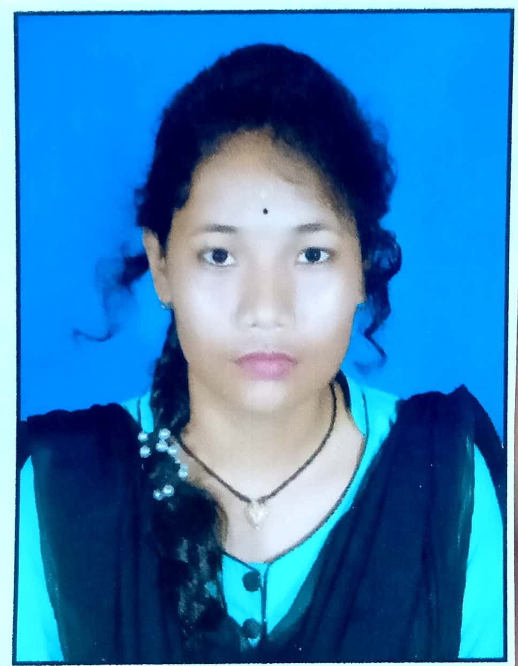  At:- Uthuli  Po:- Bahala  Dist:- Balasore  Odisha – 756060
Mobile: | (+91)9658244164
Email: | Namitasethi624@gmail.com

Objective: | To acquire knowledge and improve skills and utilize them. To take responsibility and accept challenges in work for self –development. I want to be one of the best employees of the organisation through my hard work, loyalty, sincerity & dedication.
Educational Qualifications
- Continuing Graduation in Arts with Odia.(Hons) from Nilgiri College, Balasore, Odisha

- +2 Arts . from Nilgiri Women’s Jr. College, Nilgiri, Odisha.

- 10th from Udasjamuna Uchhavidya pitha,Gadiamal, Odisha .

2018

2016

Technical Skills:
 | PGDCA with getting knowledge in computer MS ward, Excel , power point & internet etc.
Strengths:
- Leadership and Managerial Skills
- Comprehensive problem solving abilities
- Hardworking and Dedicated
- Confident about my Abilities
Hobbies & Interest:
- Listening music
- Playing Cricket
- Travelling & Making Friends

Personal Details:
Date of Birth: | 02 may2000
Gender: | Female  Indian  Oriya  English, Hindi and Oriya
Nationality: | Female  Indian  Oriya  English, Hindi and Oriya
Mother Tongue: | Female  Indian  Oriya  English, Hindi and Oriya
Language Known: | Female  Indian  Oriya  English, Hindi and Oriya
Marital Status: | Un Married
Category: | SC

Declaration
I hereby declare that the above-mentioned data is true to the best of my knowledge.

Date: (Namita Sethi )
Place: Balasore Signature

