CURRICULUM VITAE
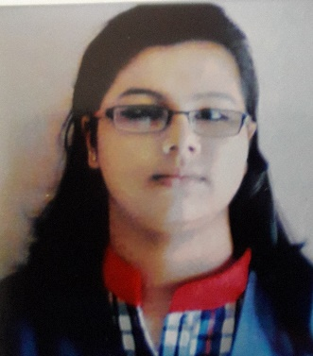

Name- Manisha Rath
Mobile- 7008070472, 8093439721
E-Mail manishamegha1331@gmail.com

Academic Qualification
EXAMINATION | INSTITUTION | Board/University | YEAR of passing | DIVISION | PERCENTAGE of marks
MBA | B.J.B Autonomous college | Utkal University | 2019 | First  Class | 64.5%
BBA | B.J.B Autonomous College | Utkal University | 2017 | Second class | 50.5%
+2 | Kendriya Vidayalaya College | C.B.S.E | 2014 | First  Class | 61%
10th | Venkateswar English Medium School | I.C.S.E | 2011 | Second Class | 52%

AREAS OF Strengths
- Honesty.
- Good communication Skill.
- Positive Attitude.
- Effective Time Management.
- Leadership skill

PROJECT DETAILS
- BBA PROJECT :- ( A PROJECT REPORT ON “ A STUDY ON EFFECTIVENESS OF 4P’S ON CUSTOMER’S AT BRAND FACTORY WITH SPECIAL REFERENCE TO BRAND ‘W’ ”)
- MBA PROJECT :- ( A PROJECT REPORT ON “IMPACT OF TRAINING AND DEVELOPMENT ON EMPLOYESS PERFORMANCE AT NALCO” )

Work EXPERIENCE
  - Worked at Aakash as Academic Executive for 2 months

  - Worked at ApnaMBA.com as Sr. Academic Counsellor for 10 months

  - Currently working at Vedantu as Academic Counsellor from September 22nd,2020

Personal Information

Date of Birth : 31.03.1996
Father Name : Sushant Rath
Marital Status : Unmarried.
Nationality : Indian.
Religion : Hindu.
Language known : English, Hindi, Odia.
Present address : Plot no 852 flat no 05 prava apartment madhusudhan nagar unit 4

declaration
I hereby declare that all the above-furnished information is true to the best of my
knowledge and belief.
Place: Bhubaneswar.
Date : 27.04.2017
