CURRICULUM VITAE
Name : BENUDHAR SAHU
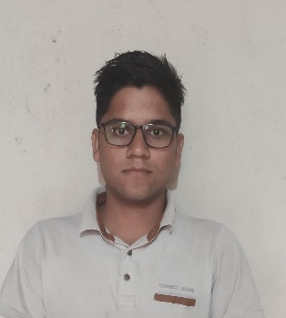
Address : Jhojhanara, Dava, Bargarh-768042
Mobile No : 7735028208/9668175609
Email : caunique1998@gmail.com
Apply For : Accounts Dept

PERSONAL DATA
Nationality : Indian
Sex : Male
Marital Status : Single
Date of Birth : 11th Jan 1998
Place of Birth : Jhojhanara, Dava, Bargarh-768042
EDUCATION
2017 onwards : Inter (IPCC) Student at ICAI (The Institute of Chartered
Accountants of India)

2014-2017 : Bachelor of Commerce from Gangadhar Meher (Auto) college,
Sambalpur
2012-2014 : Studied at Panchayat Junior College Higher Secondary
ADDITIONAL TRAINING
2017-2020 : Completed 3 Years of Articleship training from S.K.Singhania & Co
(In the field of Accounting, Taxation, and Auditing)
2017 : Completed Orientation Program & Information Technology
At ICAI (The Institute of Chartered Accountant of India), BBSR
2014 : Has successfully completed PGDCA (Post Graduate Diploma
In Computer Application) form I-Tech Academy

