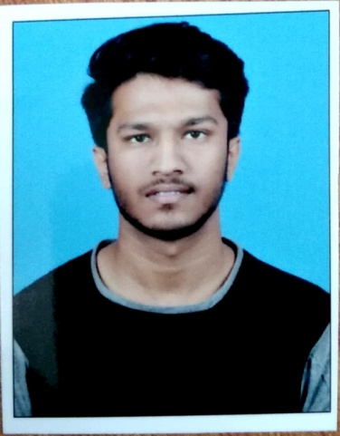
Rajat Patel
c/o - Ashok kumar Patel
D.L.Bhawan, Near shiva temple
modipara
Sambalpur - 768002
Mobile no: 8280768530
Email- prajat247@gmail.com

OBJECTIVE:
To Acquire A Challenging Position In An Environment Where I Can Best Utilize My Skills And Education and try to learn all aspects of the job in the organisation. To enable a strong potential in my career development and also helps in organisation growth who provide a better work environment.

EDUCATION:
- Gangadhar Meher University(PERSUING)
Master of Commerce 1st semester 7.32 SGPA
- VIKASH DEGREE COLLEGE (AFFILITATED TO SAMBALPUR UNIVERSITY)
April, 2019 B.COM 8.07 CGPA
- G M Junior College, Sambalpur
March, 2016 CHSE 64.83%
- Saraswati Vidya Mandir, Dhanupali
March, 2014 BSE 73.5%

TECHNICAL SKILLS:
- Well acquainted with Tally
- Well acquainted with Marg (Business Software)
- Basic knowledge of Computer (including ms-word, ms-excel, ms-powerpoint)

EXTRA CURRICULARS & ACCOMPLISHMENTS:

- Elected as class representative in school and college.
- Active participation in science exhibition and other mathematical exam.

HOBBIES:

- Listening music
- Reading motivational story
- Watch motivational video

PERSONAL SKILLS:

- Sincere
- Positive attitude
- Focused on achievement of targets
- Flexible & Adaptable
- Good listener & quick learner

OTHER PERSONAL INFORMATION:

Father’s Name: Ashok Kumar Patel
Mother’s Name: Jharana Patel
Date of birth: 31st December 1998
Languages known: English, Hindi, Odia, Sambalpuri
Nationality: Indian
Strength: quick adoptability

Place: Sambalpur
Date: 01-01-2021 Rajat Patel

