 |  |  | 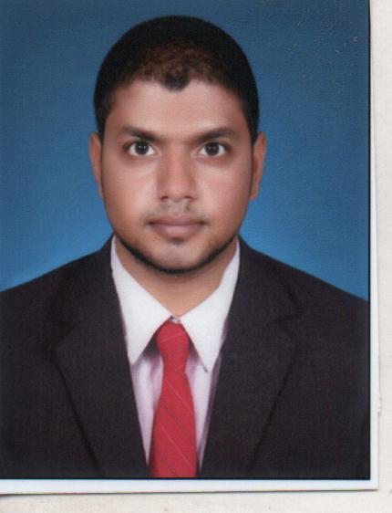
  ANUP KUMAR RAJ
  Phone: +91 9583109603
  +91 9437738650
  E-Mail : anupkumar.raj19@gmail.com
  Address : Kasidiha,Ambliatha, Jaleswar,Balasore
Professional Summary
Public Relations Specialist with vast experience managing external public relations and media agencies.Skillfilly manages multiple tasks and meets tight deadlines in high-pressure environments.Accomplished good customer relations specialist with experience effectively promoting and enhancing robust community relations programs and maintaining active and positive relationships with business and the community.

 |  | Affiliations
- Proficiency in cultivating positive rapport and nurturing relationships by offering services beyond expectations.
- Identified prospective clients, generated business from new accounts and developed them to achieve the consistent profitability; discovered new streams for revenue growth &formulated plans to build consumer preference.
- Skilled in acquiring, developing & servicing long-term relationships with corporate clients; prospecting & identifying new leads and pitching to the clients for achieving targeted business.
- Excellence in ensuring speedy resolution of queries & grievances to maximize client satisfaction levels.
- Forecasted monthly / annual sales targets and executed them in a given time frame.
- Ensured strict adherence to organization banking rules, regulations & procedures.
- Meets goals through strategic business planning and innovative initiatives.
- Advanced abilities in term building and workflow improvements.Innovative and analytical with project management skills.
Work Experience
- Since August 2020:ICICI LOMBARD GENERAL INSURANCE LTD as UNIT SELLS MANAGER.
- Since june 2019 to July 2020: ADITYA BIRLA CAPITAL(ABSLI) as HDFC BANK RELATIONSHIP OFFICER .
- Managing complaints and requests,client engagement and product penetration.
- Explained and documented for clients the types of services to be provided,and the responsibilities to be taken by the personal financial advisor.
- Managing 3 branches in Insurance Bussiness Also Agency vertical and achieved target.
- Cross sell of various product(i.e-PL,Creditcard,Auto Loan,RD,Fd,Saving/Salary/Current account,etc
- Recruiting Effective agent and Motivate them for Bussines .

Qualification
- Studying MBA In KBS,Bhubaneswar Under Biju Patnaik University of Technology.
- Completed B.Tech(Mechanical) In College of engineering, Bhubaneswar Under Biju Patnaik University Of Technology With Current CGPA 6.81.
- Completed +2 From UN College, Nalagaja With Percentage 64.9
- Completed 10th From Jaleswar High SchoolJaleswar With Percentage
73.1

Awards/ Achievements
- Awarded Star Performer by respective cluster head.
- Awarded For Top Performer by Zonal head on RNR Programme
- Target Acheiver.
- Winner in badminton tournament.(At school level)
- Selected as Captain in my college cricket team.
- Best player in Inter college tournament.
- Due to my Leadership skill and team management selected as a event organizer in college.
- Also arrange social activities like Blood donation in my locality.

SKILL Set
- Strong verbal and communication skill.
- Problem analysis and solving skill.
- Maintains confidentiality.
- Quick decision making.
- Leadership

IT Skill
Operating systems : Windows vista,windows 7,Windows 8,Windows 8.1,
Windows 10,Linux
Languages : C, C++(basic knowledge)
Database : DBMS

- Well known in M.S office and M.S word.
- Worked with Flexcube and CRM system.

Hobbies
- Playing Cricket
- Event Planner
- Internet suffering and Collecting Biography.
- Sketching still life.

Personal Details
Fathers Name : AhindraNath Raj
Gender : male
Date of Birth :5thJuly 1994
Marital status : Single
Nationality : Indian
Languages Known : English,Hindi,Odia and Bengali

Personal Strength
- Hard Worker
- Quick learner
- Positive Approach
- Problem Solving
- Team player
- Success oriented

Declaration
I hereby declare that the above furnished information are true to the best of my knowledge and belief.

Date Anup Kumar Raj

