CURRICULUM VITAE

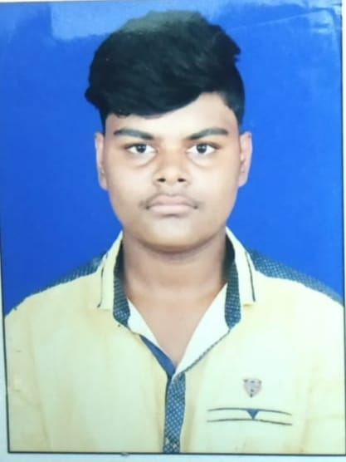
Kanha Patra
Email id: kanhapatra45@gmail.com
Contact no- 8093587220

OBJECTIVE
Looking for an exhilarating career in accounts with an organization of immense repute, which demands the best of my professional ability in terms of excellent analytical, organizational and communication skills.
PROFESSIONAL SYNOPSIS
- Knowledge in accounts, always try to solve problems with hard working, dedicated towards the goal.
- Initiative for taking new responsibilities and high Interpersonal skills.
- Like to interact with People to know them, understand and help them to solve their problems & ability to establish teamwork.
- Good communication, analytical and interpersonal skills
EDUCATIONAL QUALIFICATIONS
QUALIFICATION | SCHOOL/  COLLEGE | BOARD/  UNIVERSITY | YEAR | PERCENTAGE/  CGPA
B.COM | PNAUTONOMOUS COLLEGE, KHORDHA (ACCOUNTING HONORS ) | CHSE ODISHA | 2020 | FIRST DIVISION
CLASS XII | ODM PUBLIC SCHOOL ,BHUBANESWAR | CBSE ODISHA | 2017 | 67%
CLASS X | ODMPUBLIC SCHOOL, BHUBANSWAR | CBSE ODISHA | 2015 | 85%

COMPUTER PROFICIENCY
- Tally ERP
- MS-WORD, Advance MS-EXCEL, MS-PowerPoint

INTERESTS / EXTRACURRICULAR ACTIVITIES
- Cricket, Football, Badminton, Chess
- Competitive Coding

PERSONAL PROFILE
Name : Kanha patra
Father’s Name. : Ch. Sudarsan patro
Date of Birth : 04/10/1998
Permanent Address : MIG-II - 16/6, Bda Colony, Chandrasekharpur, Bhubaneswar.
Marital Statu. : Single
Nationality : Indian.
Languages Known : English,Hindi,Odia

DECLARATION
I do hereby declare that the above information is correct to the best of my knowledge and belief.

Date: Yours sincerely
Place: Kanha Patra.

