RESUME
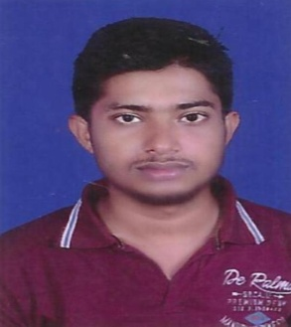
SOUMYA RANJAN MISHRA
Mob: - 9583887450
Email:- soumya88745@gmail.com
Contact Address: Soumya Ranjan Mishra
C/o-Shishir Kumar Mishra
At:-Sagadipal
Po: Nalam
Via/Ps: Kaniha
Dist : Angul
Pin : 759117

Career Objective

I would endeavor in an environment where I could make significant contribution to the organization while enhancing my skill further. In the long run to excel in the technical field with a challenging job so as to scale new heights of excellence and undertake new responsibilities with extra commitment.

Educational Qualifications

- 10 th Pass from BSE, Odisha 2009 with 57.33%
- Intermediate from CHSE, Odisha 2011 with 47%
- +3 science utkal university 49.28%
- PGDCA in computer oritech odisha

Extra Qualifications

- Two Year Technical Course from SCTE&VT

Software Exposure

        - MS Office 2007,2003
        - Windows-XP
        - Windows-7
        - Multimedia

Project Work

- Gas Chamber
  - On 10th March 2014

Point For Self

- Self motivated with Positive attitude.
- The ability to work in team.
- Adaptable to the changes in my surroundings.
- I take initiative to improving the things and convince others to join me.
- Interested in exploiting my theoretical knowledge as practical .
- Helping others.

Extracurricular Activities And Interest

- Listening soft music and watching cricket.

Personal Profile

Date of Birth : 02- Feb- 1994
Marital Status : Single
Sex : Male
Blood Group : O+VE
Language Known : English, Hindi ,Odia
Nationality : Indian.

Deceleration

I declare that above data given are in my knowledge & if any mistake is to found than I will be only responsible for it .

Date :
Place
Soumya Ranjan Mishra

