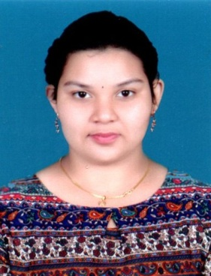
CURRICULUM VITAE
SWAGATIKA BAI
E-mail:-swagatikabai534@gmail.com
Contact:-+919348724122
Present/Permanente:- At- Thanasahi Talcher Town
Po- Talcher Town
Ps-Talcher Sadar
Dist-Angul
Pin-759107 (Odisha)
Career Objective:
Seeking a challenging job that utilize and further sharpen my skills and where I can express my thoughts and ideas for the growth of the company.
Academic Qualification:
Qualification | Name of institutions | Board/ University | Percentage/ CGPA | Year of passing
10th | SSVM, Talcher Town | BSE ODISHA | 65.66% | 2015
+2 (Science) | TTPS Higher Secondary School, Talcher Thermal | CHSE ODISHA | 49% | 2017
Graduation (Commerce) | Talcher Autonomous College, Talcher | UTKAL UNIVERSITY | 57% | 2020
Computer Skills:
- Basic Computer Knowledge.
Strength:
- Self Motivator
- Good Listener
- Multi Taxing
- Positive Thinker
- Hard Worker

Hobbies & Interest
- Reading Books
- Exploring New Things
- Dancing

Soft Skill
- Good Communication

Personal Details:
- Father’s name : Lt. Dharmendra Bai
- Mother’s name : Laxmi Bai
- Date of Birth : 31.03.2000
- Nationality : Indian
- Religion : Hindu
- Marital status : Bachelor
- Gender : Female
- Blood Group : B ve+
- Language known : Odia ,English, Hindi,
Declaration
I do hereby declare that all the above-furnished information is true to the best of my knowledge and belief.
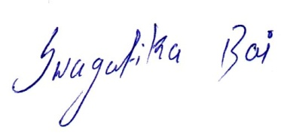

Signature

