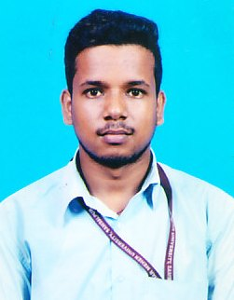
CURRICULUM VIATE

DHARANIDHAR PRADHAN
Dist- Sambalpur
Mob:7008369296
Email. ID:- pradhandharanidhar98@gmail.com

CARRIER OBJECTIVE :

I value sincerity in whatever I do and honesty is the crux of my personality. My strengths include hard labour, good communicating skill, courage and positive attitude towards life.

EDUCATIONAL QUALIFICATION:

- Matriculation from B.S.E (Odisha) Board in the year 2013 securing 65.5% from Jagannath High School , Itee (Bandhabhuin)
- +2 (Commerce) from C.H.S.E (Odisha) Board in the year 2015securing 56.5% from GM Junior College, Sambalpur
- B.Com from GM University, Sambalpur in the year 2018 securing 5.46 CGPA.
- MBA from Sambalpur University, Jyotivihar ,Burla in the year 2021.

Extra Qualification:
- PGDCA from I-TECH, Sambalpur.
EXPERIENCE:
- One year experience in sales promotion of Hamlai Lubricants.
PERSONAL INFORMATION:
Name : Dharanidhar Pradhan

Father Name : Nilambar Pradhan
Mother Name : Manjari Pradhan
Gender : Male
Religion : Hindu
Nationality : Indian
DoB : 19th Apri 1998
Address : At- Naxapali,
Po- Maneswar,
Ps-Dhanupali, Dist- Sambalpur, Pin-768005
Caste : OBC
Martial Status : Unmarried
Language Known : Odia, Hindi, English
Hobbies : Cricket, Badminton
Declaration

I hereby declare that all the statement made in the Curriculum Vitae is true and correct to the best of my knowledge & belief. If any information being found false or incorrect appropriate action can be taken against me.
Place: Sambalpur
Date: Signature

