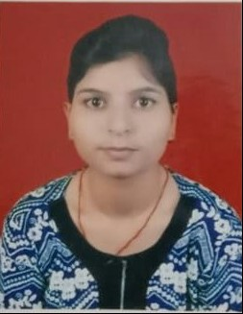
POOJA PARMAR

Contact Details:
Current Address: Personal Data:
Shiv Colony, Pinto Park, Gender:- Female
Morar, Gwalior (M.P) DOB:-10th Aug 1996
Pin - 474005 E-mail:-pp3627661@gmail.com
Mobile No: +91 8602460887

Career Objective: -
I would like a career that gives me rich exposure through diverse assignment and working with people of high caliber. I would constantly look out for challenges, which would help me to achieve my personal as well as professional goal.

Professional Qualification:-

MBA – Masters in Business Administration, Approved By Jiwaji University Gwalior.
Batch 2017-2019.

Major --- Finance Minor --- Marketing

Semester | 1st | 2nd | 3rd | 4th
Marks % | 56 % | 67 % | 70 % | Pursuing

Academic Records:
Education | University/College Name | Year of Passing | Result
B.com | Jiwaji University | 2017 | 53%
S. S. C. | Samrat Public High School | 2013 | 47 %
H. S. C | Samrat Public High School | 2011 | 42 %

INTERNSHIP DETAILS
Industrial Training:-

- Internship
Organization : GUPTA BAJAJ FINANCE, Gwalior

- Area : Corporate Finance
- Duration : 45 days
- Learning : Checked Invoices, Store Audit. Office Financal work. File
updatation, Information of Schemes, Keeping Records etc.
.

Computer Proficiency:-
- Operating Systems: Windows (XP, 7,8,10)
- MS OFFICE

Hobbies:
- Travelling, Teaching, Reading book
Declaration:-
I hereby declare that the above-mentioned information is correct up to the knowledge and I bear the responsibility for the correctness of the above- mentioned particulars

Date: 19/09/2019
Place: Gwalior (Pooja Parmar)

