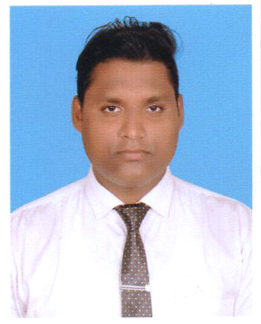
BISWAJIT BEHERA
AT/PO:TORA SPINING MILL CANAL COLONY,TORA
DIST: BARGARH, ODISHA(768040)
MOBILE NO:,8093470467,8249838596
EMAIL ID:-biswab97@gmail.com

Career objective:

.To work for the organization to the best of my knowledge
and ability from where the organization could benefit from my service and provide me with knowledge that are professionally important to me.
Educational Qualification :

Level | Year of Passing | Board/University | Major Subject Optional | Percentage
Matriculation | 2008 | HSC |  | 57
+2 Science | 2012 | CHSE | PCMB | 55
Graduation | 2015 | North Orissa University | EFML | 58
DIPLOMA IN ELECTRICAL | 2020 | SCTE&VT,ODISHA | ELECTRICAL | 59.6

Professional Qualification & Experience:

- Diploma in electrical branch at Govt.Polytechnic,Bargarh .
- Post graduate Diploma in Computer and Application, Networking.
- CCNA,Windows Server,Autocad,PLC, Data structure ,C,C++,Python, Switchgear and Driver.
- I worked in In2it Technologies PVT LTD, Bhubaneswar as a Residential Engineer in the year 2017-2020.
- Now I am working in Printlink Computer & Communication Pvt.Ltd as a Network Engineer.

Curricular Activities :

- I was a district level Cricket Player.
- Take Participate in College annual Program and outdoor trip.

Strength :

- Willingness to learn more, Explore new and innovative ideas.
- Ability to take Challenging jobs.

Skill Summary
- Customer service
- Front desk management
- Telephone etiquette
- Computer literacy
- Marketing Analysis

Hobbies and Interests :
In Hobbies surfing internet and playing out door game.

Personal Details :
Father Name : SASANKA SEKHAR BEHERA
Mother Name : ALPHA RANI BEHERA
At/Po : TORA SPINIGMILL CANAL COLONY TORA
Police station : BARGARH
Dist. : BARGARH
State : ODISHA
Date of Birth : 27 JUNE 1992
Nationality : INDIAN
Marital status : SINGLE
Sex : MALE
Language Known(R/W/S) : ODIA, HINDI, ENGLISH, BANGALE

Declaration

I hereby, declare that the above-mentioned details are true to the best of my knowledge and belief.

Date:

Place: (Biswajit Behera)

