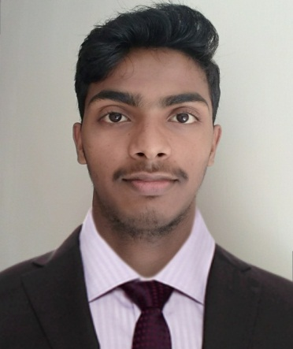
CURRICULAM VITAE
DILLIP KUMAR DEY
Mob :+91 9284512728
Email:dillipkumardey895@gmail.com

Career Objective:
To gain experience in the field of accounting and also utility my skills, in order to increase productivity of organization and individual growth.
Skill Sets:
Thorough knowledge of Accounting
Strong analytical, problem solving, organizational ability,
Written, communication skill and a quick learner.
Ability to dill with people diplomatically.
Willingness to learn.
Educational Qualification:
B.Com from F M University, Balasore, Odisha – 2016
12th Commerce from Rural Institute of Higher Studies Bhograi, Balasore, - 2013
H. S.C.E. from HC Academy, Bhograi, Balasore, Odhisha – 2011

Certification
PGDCA (Post Graduate diploma in Computer Application)
Tally -9.0
From Rural Institute of Higher Studies, F.M University Bhograi, baleshwar, Govt of Odisha.
Internet experience
M.S Office, word, excel, power point, etc.
Typing speed (Average/35 w.p.m)
Work Experience
- Worked as an Accounts Assistant at THE OCEAN PARK RESORT, ( 4 star ) CALANGUTE, GOA for 6 month.
- Worked as an Accounts Assistant at LA CALIPSO / CASINO PALMS, ( 5 star )BAGA, GOA for 1year.
- Worked as an Accounts Assistantat LASUNILASUITES,BAGA,GOA(4star)from 9th October 2017 to30th October 2019 for 2 years.
- Presently working as a Senior Associate/(C&A) at Reliance Retail Limited from 05/09/2020

Worked in software
Tally - 9.0, IDS cashier & accounts module, Lucid cashier module, eZee cashier module, Hotel logix, SAP, MM, FI
Personal Details:
Date of Birth - 25th May 1996
Language –Odia, Hindi, English & Bengali
Hobbies –Painting, Designing, Reading News Paper, Playing, Watching TV
Marital Status – Unmarried
Permanent Address: - At – Kasimpur , Po – Malaruan
Ps – Bhograi, Dist – Balasore
State – Odisha, Pin – 756038
Date -18/10/2021
Place -Balasore Dillip Kumar Dey

