JANARDAN SAHU

Permanent Address: |  | 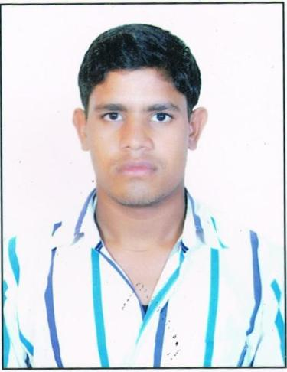
VILL+POST-KHOPALI
DIST.- DURG (C.G.)
PIN CODE-491107
(Mob): +91-9179475470
Email id:janardansahu30692@gmail.com

Objective:
To gain a dynamic and challenging role that will offer me the best opportunity for further development of my abilities, skills and knowledge in an established firm with long term career growth possibilities.
Academic Qualification

Course | Institution | Board /University | Year of Completion | Aggregate (%)
B.E  (MECH.) | Shri Shankaracharya Institute of Engineering & Technology, Bhilai | CSVTU | 2014 | 69.53
12th Board | Govt. High. Sec. School,  Utai | CGBSE | 2010 | 74.8
10th Board | Govt.High School,  Khopali | CGBSE | 2008 | 65.83

Areas of Interest:
- POWER PLANT ENGINEERING
- MANUFACTURING TECHNOLOGY

Experience:

  - 4 YEAR EXPERIENCE IN PATRA INDIA AS PROCESS EXECUTIVE - 3

Training:
- SIMLEX CASTING, Bhilai
- BHILAI STEEL PLANT, Bhilai

Academic Project:

Project Title : | FABRICATION AND MODELING OF ADVANCE VEHICLE
Description: It is an advanced featured vehicle that rotates there wheels 90 degree.

Personal Skills & Hobbies:
    - Confident, Energetic and hardworking,
    - Positive Approach, Leadership qualities,
    - Hobbies are Playing Cricket, Football.

Achievements & Extra Curricular:
- Participated in Robotics & gully cricket.
- Actively participated in various cultural activities, Sports.

Personal Profile
- Date of Birth : 30/06/1992
- Gender : Male
- Fathers name : Leeladhar Sahu
- Mothers Name : Rewati bai
- Mother Tongue : Hindi
- Nationality : Indian
- Marital Status : Single
- Languages Known : English , Hindi

Declaration
I hereby declare that the above information's are true to best of my knowledge.

PLACE: UTAI JANARDAN SAHU

