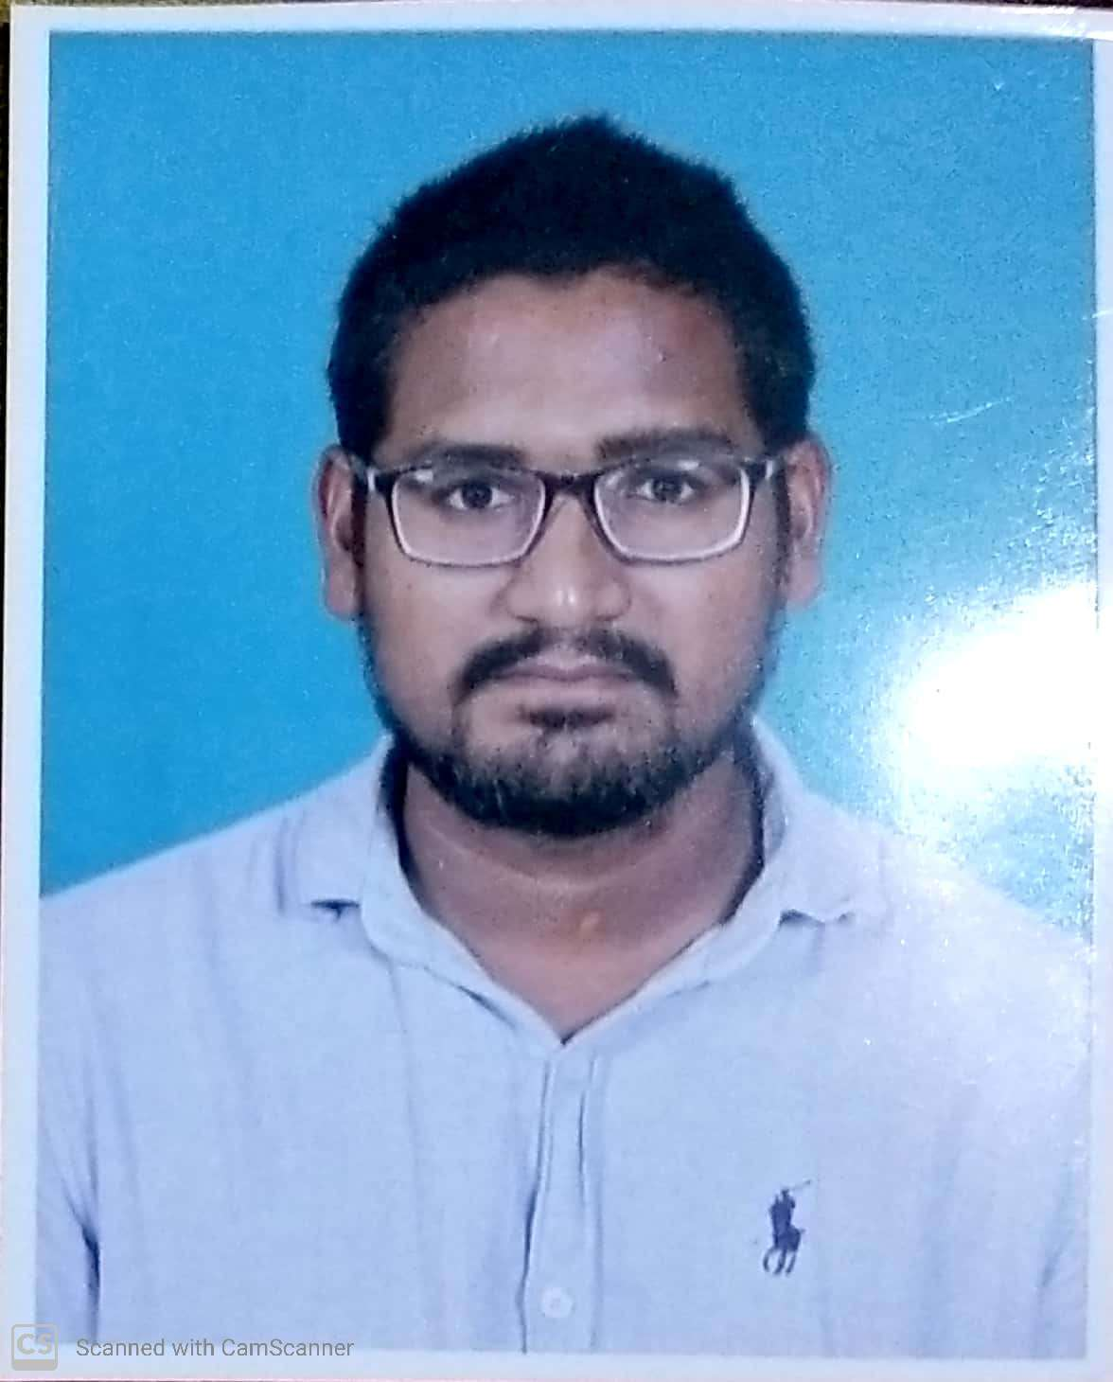
BISWASAMRAT DEBADUTTA
Present/permanent Address
C/o: ✓Naresh ch. Behera
At /Po: Hemasurapada/angul
Dist. Angul
Pin : 759122
Mob.8249511819
E-mail: devduttasamrat@gmail.com

CAREER OBJECTIVE:

To enhance my skill set by working in a challenging & competitive environment, contributing to the growth of the organization and self.

CURRENT WORK EXPERIENCE PROFILE

Experience : 2years
Company : HINDUJA lEYLAND FINANCE, ASTRAL PIPES , BLACKBUCK ,
ANGUL
Désignation : Marketing executive
Duration : 11 Nov 2019 to 20 Nov 2021

EDUCATIONAL QUALIFICATION

- Passed Matric under BSE, Odisha in the year 2010 with 71.67 %.
- Passed deploma in civil under SCEVT, Odisha in the year 2015 with 86.50 %.
- Passed +3 Com under UTKAL University in the year 2018 with 62%.

COMPUTER SKILLS

- Good knowledge in Microsoft Office
- Net Browsing & Operating.
- Good typing speed.

ACADEMIC ACHIEVEMENTS

- Take part in different school sports events.
- Work as a leader in school & colleges for different works & events.
- A good student for my teachers.

STRENGTHS

- Responsible for maintaining a deep understanding of marketplace trends and competitor activity.
- To pro-actively devlop new opportunities in fresh Markets.
- Business to business and business to client communications.
- Carrying out intense and detailed negotiations with clients and cultivating storng relationships with clients.
- Ensuring customers enquiries and orders are properly managed and processed in a timely manner.
- Have effective communication skills and a keen eye for detail and the ability to win new and existing business.

PERSONAL PROFILE

Name : Biswasamrat debadutta
Fathers Name : ✓Naresh ch. Behera
Mother's Name : Sanjukta Behera
DOB : 1st April 1995
Sex : Male
Marital Status : Un-married
Nationality : Indian
Religion : Hindu
Language Known : Oriya, Hindi & English

DECLARATION

I hereby solemnly declare that all the statements made above are true & Correct to the best of knowledge & belief. I promise that it will be a value addition to your organization as well as for myself.

Place: ( Biswasamrat debadutta )

Date:

