CURRICULUM VITAE

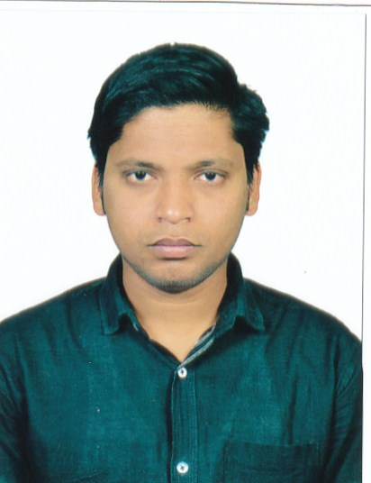

Contact Information
Name- MANAMOHAN SAHOO
Qr no-16/4, Type-ΙΙ, Unit-ΙΙΙ,
Kharavela Nagar,
Bhubaneswar- 751001
Dist- Khurda
Orissa
Email Id- manamohansahoo23@gmail.com
Mob No. - 9777229321

Personal Detail
Name- MANAMOHAN SAHOO
Date of birth – 05/07/1991
Father’s Name- MADHUSUDAN SAHOO
Mother’s Name – SEBATI SAHOO
Gender- Male
Caste- GENERAL
Religion- Hinduism
Nationality - Indian

CAREER OBJECTIVE
To employ my hard work and dedications with a professional organization to achieve greater heights in life.

ACADEMIC QUALIFICATION
Year | Qualification | School /  College | Board /  University | %
2008-11 | +3  Commerce | Ekamra  College | Utkal  University | 49.99%
2006-08 | +2  Commerce | Acharya  Harihara  College | C.H.S.E  (Orissa) | 43.34%
2006 | 10th | CAPITAL HIGH SCHOOL | H.S.E. | 61.64%

COMPUTER SKILLS
Passed PGDCA certificate from AMRUTANSU COMPUTER ACADAMY.

LANGUAGES KNOWN
Oriya, Hindi & English.

EXTRA- CURRICULAR ACTIVITIES
- Participated in various athletics programmed in school
and College.
- Passed NCC ‘C’ certificate from Air Wing.

HOBBIES & INTEREST
- Interacting with new people.
- To play Cricket.
- To listen songs.

STRENGTHS
- Leadership qualities.
- Positive Attitude.
- Self Confidence.
- Be Positive.

EXPERIENCE

One year experience as an accountant executive in Leisure house Pvt Ltd.
Four year experience as an junior executive in travelarrangers.in.

DECLARATION
I hereby declare that all the information stated above is true to best of my knowledge and belief.

Date-
Place:-Bhubaneswar (manamohan sahoo)

