HIMANSU KUMAR MALLICK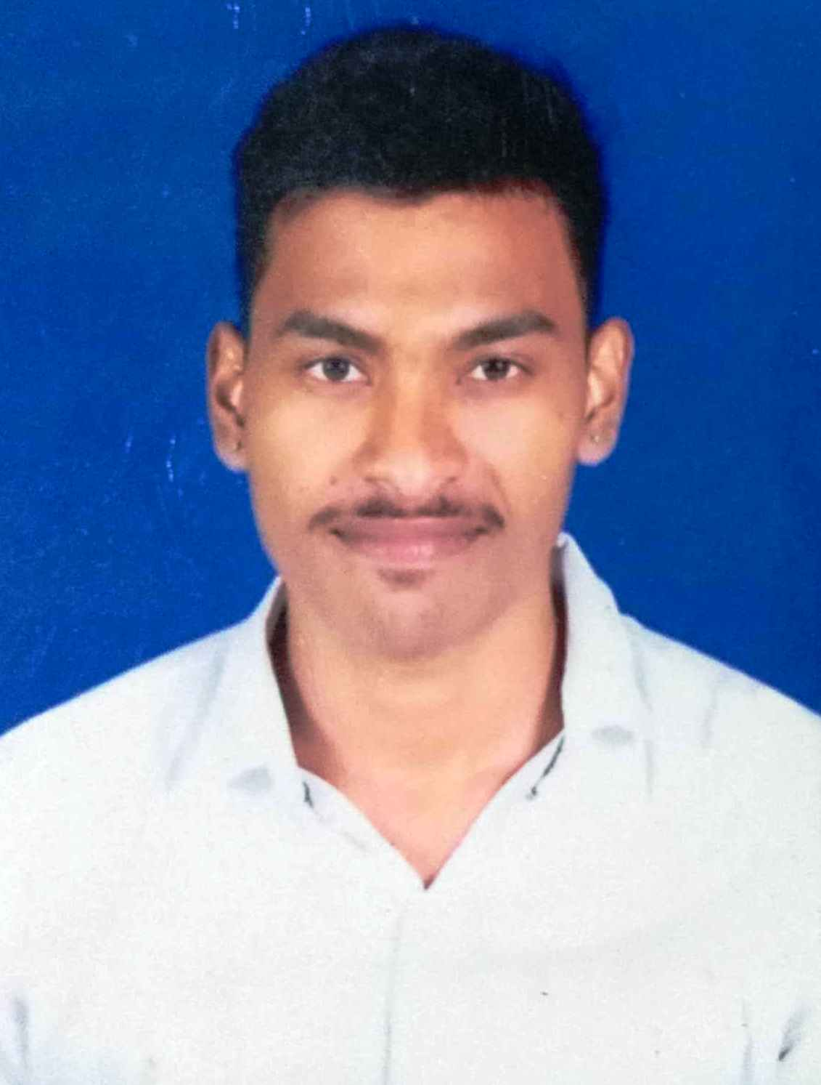
Cell: 9337176054; E-Mail: himansukmallick@gmail.com
Present Address:At-Sartol, Po- Nayabazar, Ps- Madhupatna, Dist- Cuttack, Pin- 753004, Odisha.
Permanent Address: At-Sartol, Po- Nayabazar, Ps- Madhupatna, Dist- Cuttack, Pin- 753004, Odisha

Executive Profile:
- A person with a strong positive attitude having sound knowledge in the domain of Marketing Services Analytics.
- To seek a challenging position in an organization that encourages continuous learning, innovative thinking & offers me the opportunity to explore career possibilities and development.
- Hands on experience and knowledge in all of Marketing and sale strategies with well understanding of various Marketing strategies, such as targeting, segmentation and differentiation and positioning etc.
- A result-oriented individual with the proven ability to work efficiently in a team.
- Believe in 7 p’s ; product, price, place, promotion, people and physical Evidence , to set the target market.
- Self-driven, focused and hard working with strong analytical and problem solving skills.
- Strong ability to maintain the highest possible level of confidentiality.
Technical Knowledge: PGDCA including MS Office 2007 & 2010 (Word, Excel, Power Point) with tally.

PROFESSIONAL EXPERIENCE
■ working now at Reliance Retails.
■ 1 years of experience in the area of marketing and sales fields at Google pay.
■ 1year experience at Ruchi Spices Pvt Ltd. in the field sales and Marketing and sales promotion.

Different Work items & Tools Utilization:
- Helping other sub-ordinates worked on Different conditions and overcome from to achieve targets.
- Utilized Tools like 7 p’s , Marketing Strategies to achieve my goals.

Achievements:
- Have taken part in various Quiz & Debate competition in school and college level.
- Have represented the school in various other activities.
EDUCATIONAL QUALIFICATIONS

  - MBA in DRIEMS Management College under BPUT
  - B.Com (Commerce Honors ) from F.M. AUTONOMOUS COLLEGE , under FAKIRMOHAN UNIVERSITY in 2019 Odisha.
  - Passed +2 (science) from LR. D.A.V COLLEGE, under C.B.S.E Board in 2016, Odisha.
  - Passed Metric (10th) from LR. D.A.V public SCHOOL under C.B.S.E Board, Odisha in 2012.
INTER PERSONAL COMPETENCIES

  - Positive Attitude and self motivated
  - Time Management and disciplined
  - Hard working, Quick Lerner and always eager to learn new things
  - Good Communication and soft skills
  - Planning and Problem Solving Skills
  - Thrive in a team environment and work well with others
  - Delegating tasks or responsibilities
  - Adaptability

HOBBIES

  - Listening music, Singing and meeting people.
  - Watching News channels sports reading newspaper.
  - Meditation – Yoga & Meditations.
  - Interested to do new projects.
OTHER PARTICULARS

  - Gender: Male
  - Date of Birth : 20/08/1994
  - Father's Name: Mr. Hemant Kumar Mallick
  - Languages Known: English ,Hindi and Odia
  - Nationality: Indian

