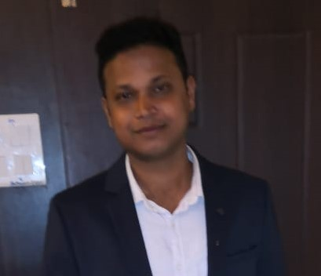
Rajendra Prasad Das
QR No-GL/2
VSS Nagar,Bhubaneswar
E-mail- rikun.das@rediffmail.com
Mobile-07752003261

Objective:
- To use knowledge to derive the best possible result and to continuously learn new things this helps me to use my knowledge even better.
- •Seeking a bright &challenging career in the field of sales and marketing

- To constantly upgrade my knowledge and skills and make a difference in whatever I do.

My Strength:
- My hard working nature and confidence is my strength, which makes me to achieve the goals. Immense thirst to gain more knowledge, that which makes me a quick learner.

Career at work

HUGHESNET GLOBAL EDUCATION (From 08-03-2011 to 08-05-2013)

Sales Coordinator (Bhubaneswar)
- handling the operations, Selling of executive course from Premium institute of India
- Conduct the classes, coordinate with institutes.
- Facilitates conducive environment and marketing and business development efforts.
- Responsible for taking appointments for different customers, Handled the tasks of dealing with customer queries.
- EDP (Electronic Data Processing ) of information on Management Information & Data Access System (Midas).
HCL INFOSYSTEM PVT LIMITED From (27-10-2013 to 12-05-218)
Sales Officer (odisha)
- Dealing with Nokia Devices & Gear Products. Manage and drive sales through distribution channel.
- Responsible for the distribution strategy at the channel-partner level. Execute promotional activities for channel partners to drive sales and build market credibility.
- Deliver sales target for all products. Achieve retail expansion targets through increase in number of outlets in existing and new geographies.
- Help management in forthcoming products and discuss on special promotions.
- Review their own performance and aim at exceeding their targets.
- Record sales and order information and report the same to the sales department
- ffmeetings or via telephone etc.
- Must act as a bridge between the company and its current market and future markets.
CONFIDENCE PETROLEUM INDIA LTD (from 21-10-2018 to still cont…)
Senior Asst Territory manager (Odisha)
- Achieving daily sales target
- meet regularly with existing dealers and new dealers to understand there evolving business needs.
- Maintaining daily activity report and sales report
- Establish and maintain positive business and customer relationships
- Make new Dealers.
- Build Long term, productive, and mutually beneficial relationships with existing and new dealers.
- Meet regularly with existing dealers and prospects in sales territory to understand their evolving business needs and position product solutions to meet surfaced needs.
- Work effectively with internal support departments (Marketing, Professional Services, Product Development) to promote sales for new.
- Complete sales activity reports and presentations in a timely manner

Training Attended:

- Training on Problem Solving and decision-making.

Educational Qualification:
- Master of finance &control (MFC) affiliated to Utkal University

- Graduation in Commerce (Mgt. Hons.)
Kendrapara College, Kendrapara, Orissa.

- Higher Secondary Education,
Derabish College, Kendrapara, Orissa.

- Secondary School Certificate,
Govt. High School, Unit-IX, Bhubaneswar.
Orissa State Board.

- PROJECTS: Summer internship project is has been done trading mechanism of reliance money. Dissertation is of growth of retail sector in India, a case of big bazaar
Skills & Ability:

- Excellent communication skills.
- Ability to learn new things quickly.
- Dedicated and hard working team member.
- Ability to adapt new environment very easily.

Software Literacy:

- Operating Systems : MS-DOS, MS-Office, Windows 2k, XP

Interest and Activities:
- I shared my deep interest in sports, arts and on-stage programmes. The assimilation of new knowledge has always been my ardent interest.

Contact Address:
- Qr. No-GL-2, VSS Nagar, Bhubaneswar, Orissa-751010

Personal Details:

- Date of Birth : 17th December, 1985
- Marital : Unmarried
- Contact No. : 7752003261
- Gender : Male
- Nationality : Indian
- Hobbies : Listening to music, reading, traveling,
Driving & chatting.
- Languages Known : English, Hindi & Oriya

Declaration:

- I, Rajendra Prasad Das, hereby declare that all the details furnished above are true to the best of my knowledge.

Rajendra Prasad Das

